**Final Report**

**University of Washington – WA DNR: Agreement # 93-100144**

**Activity 2**

**Fuels and restoration treatment longevity in dry forests the Western US: a review and synthesis for the Washington Department of Natural Resources**

Don Radcliffe1, Brian Harvey2, and Derek Churchill3

1 PhD student, University of Washington School of Environmental and Forest Sciences

2 Assistant Professor, University of Washington School of Environmental and Forest Sciences

3 Forest Health Scientist, Washington Department of Natural Resources

Corresponding author: Don Radcliffe, dradclif@uw.edu

**Executive Summary**

In dry forests of the western US, the longevity of fuel and restoration treatments is a critical consideration for planning wildfire mitigation and ecosystem restoration. However, scientific information on treatment longevity is sparse. For the 2019-2021 biennium, WA DNR Forest Health and Resiliency Division funded Brian Harvey’s lab at the School of Environmental and Forest Sciences at the University of Washington, to investigate treatment effectiveness, treatment longevity, and future treatment needs. Don Radcliffe is a PhD student in Brian’s lab, and led the project. Because Don was already working on treatment longevity for his dissertation, the WA DNR funding complimented funding from other sources to make up a component of his larger dissertation. Derek Churchill collaborated to represent the WA DNR Forest Health and Resiliency Division. The funding agreement stipulated three primary tasks:

1. Compile datasets that could be leveraged to answer questions about treatment longevity and long-term fuels dynamics, including ready-for-analysis datasets and datasets requiring resampling to obtain long-term data.
2. Collect field data to build on existing datasets from task one.
3. Synthesize fuels information from tasks one and two, and report on the state of knowledge in treatment longevity.

For task one, we contacted 54 fire scientists and managers who had worked in Washington state. From these contacts, we found three datasets that were well suited to addressing questions about fuels dynamics more than a decade after treatment. These were: the Mission Creek experimental study of burning, thinning, thinning plus burning, near Leavenworth, the Colville Chronosequence study of thinning plus burning, near Republic, and the National Park Service Fire Effects monitoring of thinning and burning in the North Cascades and Lake Roosevelt National Recreation Areas. We also collected information on a variety of other datasets that did not directly meet the goals of our project, see Appendix One and Appendix Two for more detailed information.

For task two, we collected additional data from the Mission Creek and Colville Chronosequence studies, 154 plots in total. We entered the data and combined them with the data for those projects that we collected for task one.

For task three, we synthesized the fuels data from our three Washington sites, compiled data from an additional six published fuels studies, and reviewed relevant literature, all to inform this report. Our analyses focused on fuels and stand structure variables in four treatment types: burning, thinning, thinning plus burning, and undisturbed ‘control’ stands.

Deliverables for these three tasks are stored in the DNR Restoration Needs folder on box.com and managed by Derek. More specific information on deliverables can be found in Appendix Three.

**Key Conclusions:**

Our literature review and data synthesis suggest some clear patterns relevant to dry forest management. Our key findings/hypotheses are:

*Treatment type*

* Thin and burn treatments showed the greatest overall effects and longevity, appearing to provide fuels reduction benefits for longer than the 20-year post-treatment window for which data were available. This is longer than previously reported rules of thumb for treatment longevity. Thinning and burning likely has greater longevity than other treatments because it addresses three important fuel components in a short time: canopy fuels, surface fuels, and regeneration, so that none of these components can build up rapidly after treatment.
* Burn-only treatments provided sustained reductions in combined litter and duff loads for longer than the 15 year post-treatment window for which data were available, while appearing to reduce other fuel components for roughly ten years.
* Thin-only treatments do not appear to provide a clear window of fuels reduction benefits, creating influxes of surface fuels in the short term and recovery of canopy fuels in less than ten years.

*Forest productivity*

* Forest productivity appears to affect absolute canopy fuel loading more than the rate of changes after treatment relative to pretreatment values, at the time scales we analyzed. In other words, longevity is often similar between more and less productive forests, but absolute fuel loads are often higher in more productive forests given similar treatment histories. Longer-term studies than we analyzed, however, might reveal faster regeneration in more productive sites, which is only weakly suggested by canopy base height data because of relatively small long-term sample size. We also did not formally analyze shrub response, which may be dependent on forest productivity.
* Forest productivity does not have a clear relationship with surface fuels, likely because higher decay rates can offset higher twig and litterfall rates at these sites.
* We analyzed forest productivity by comparing broad regional or forest type differences, and it is possible that our lessons about productivity do not apply at the stand to landscape scales at which managers operate.

*Quantification*

* There are multiple ways to define treatment longevity. The definition used will depend on the objectives for a specific site. For fuels reduction treatments where the objective is to minimize flame lengths and fire risk, longevity will likely be based on thresholds of acceptable fire behavior. In contrast, treatment longevity for forest restoration treatments, where more variable fire behavior is acceptable or desired, may be based on comparing fuel accumulation to pretreatment variables and assessing tradeoffs between retreating stands vs. treating new stands.
* Due to high variability of fuels across treatment units, relying on statistical significance to determine treatment longevity is likely to underestimate it, which could lead to inefficient resource allocation.

*Approach*

* Creating forest heterogeneity at within-stand and between-stand scales may be the safest strategy for fuels reduction at the long-term and broad-scale. There are many uncertainties about ecological and planning processes relevant to treatment longevity, so applying any one optimal treatment today could result in unexpectedly uniformly high fuel loads and/or degradation of other ecosystem values at some point in the future.

Our findings should be treated as hypotheses at this stage in our project. There is a high level of variability in dry forest ecosystems and treatment effects, so drawing statistically significant conclusions is challenging. Given this variability, the sample size of fuels treatment longevity studies is too low for formal meta-analyses. Our takeaway points are thus based on visual analysis of graphed patterns of published mean values. We will continue exploring our hypotheses in our future work on treatment longevity, which will include more detailed analyses of the three Washington datasets preliminarily used in this report, and an expansion of this review to include natural disturbances, shrub and regeneration responses, and fire modelling.

The following report is broken into three main sections:

1. The literature review section, which covers ideas in fuels treatment longevity independent of our data collection and analysis.
2. The data analysis section, which covers our process in tasks 1 and 2, presents graphs of those data, and discusses our findings in relation to the concepts covered in part 1.
3. Supplementary information, which provides additional details on a range of components of this project.

**Part 1: Literature Review on Treatment Longevity**

Forest managers and scientists of western dry forests widely support an increase in the pace and scale of fuels and restoration treatments such as thinning and prescribed burning, to mitigate the negative effects of fire suppression (see Appendix Four for a more detailed history of the wildfire problem in dry forests of the western US). Treatments can serve a variety of purposes, depending on location and details of prescription. These purposes can include:

* Reducing wildfire hazard to communities and economic assets.
* Increasing forest resiliency to wildfire, drought, insects, and disease.
* Easing fire suppression operations.
* Stimulating understory plant diversity.
* Improving habitat for open forest animal species.
* Stimulating tree growth for timber.

The short-term benefits of fuels and restoration treatments in dry forests are well-supported by many studies of fuel loads (Schwilk et al. 2009, Fulé et al. 2012) and wildfire response (Stevens-Rumann et al. 2013, Prichard and Kennedy 2014, Prichard et al. 2020). However, the longer-term fuel and vegetation pattern are less well-known, even as little as five years after treatment. Because of the relative lack of information on treatment longevity, it can be difficult or impossible for managers, landowners, and policy makers to find scientific information to help them:

* Plan optimal treatment rotations.
* Assess tradeoffs between conducting initial treatments (treating untreated stands) and maintenance treatments (re-treating ‘restored’ stands).
* Assess whether maintenance treatments can provide enough merchantable timber to help offset the cost of treatment, because much of the merchantable material is often removed in the initial treatments.
* Forecast carbon dynamics in treated stands.
* Predict prescribed fire behavior in maintenance treatments.
* Plan efficient and safe fire suppression operations in treated landscapes.
* Model future wildfire behavior in treated landscapes.
* Understand plant and animal habitat quality in treated landscapes.

Given the scope of the modern wildfire problem in fire suppressed forests of the interior west (Moritz et al. 2014, Schoennagel et al. 2017), and the limited resources available to public and private forest landowners for treatment (Jain et al. 2012, Barnett et al. 2016, Kolden 2019), researchers must address the knowledge gap in treatment longevity so that managers can efficiently plan treatment rotations and know what to expect from treated stands. In this report, we touch on some key concepts in treatment longevity from the scientific literature, and then synthesize data from all the published studies of treatment longevity that we could find from western dry forests. These include three in-progress studies led by our team, of forests in eastern Washington State. Our work is meant to highlight both what researchers know about treatment longevity, and the research gaps that remain. Our target audience includes forest managers, landowners, and policy makers working to find solutions for restoring dry forests of the western US, particularly within Washington State.

**Types of treatments**

*Fuels treatments vs. restoration treatments*

The word ‘treatment’ can apply to forest management practices with a variety goals, and it is important to distinguish between ‘fuels treatments’, which have the primary goal of reducing fuel loads to protect adjacent human values, and ‘restoration treatments’, which have the primary goal of restoring forest fuels and structure to make a stand more resilient to wildfire and other disturbances (Lehmkuhl et al. 2007, Jain et al. 2012, Stephens et al. 2020). These are ends of a spectrum of treatment goals, and most real world treatments have elements of both. Both types of treatments have similar goals of reducing overall fuel loads and opening forest structure. But for fuels treatments, potential for high severity wildfire patches and areas of torching may be unacceptable because of nearby human structures. For restoration treatments, creating forest structural variability is more crucial, because that variability confers forest resiliency to many stressors including wildfire. Restoration treatments reduce potential for severe, continuous wildfire on a landscape scale, but localized patches of high severity fire are acceptable and can even be encouraged, because these smaller patches occurred in precolonial forests and added to forest variability (Larson and Churchill 2012, Hessburg et al. 2015). Fuels treatments need more maintenance than restoration treatments, because of the sharper focus on limiting as much severe wildfire as possible, and treatment rotation length may be dictated by potential fire behavior more than tradeoffs between conducting new treatments and continuing treatments. Our work here largely focuses on restoration treatments, which will likely cover a larger portion of the landscape because they create more forest resiliency and are more feasible to maintain, and because the majority of western dry forest area is not directly adjacent to human structures (cite, maybe walk back). Restoration treatment rotations may be more dictated by tradeoffs between treating new stands and retreating restored stands, because the footprint of treated area is often small in comparison with untreated area in western dry forest landscapes (North et al. 2012, Barnett et al. 2016). We expect that many of the broad principles we address will apply to both fuels and restoration treatments.

*Initial treatments and maintenance treatments*

Treatment longevity may be very different after the first treatment of a long untreated stand, known as the initial treatment, compared to retreatments of stands, maintenance treatments, that were restored by previous treatments (Covington et al. 1997, North et al. 2012, Stephens et al. 2020). Initial treatments are also sometimes known as ‘restoration treatments,’ but we are using the term ‘initial treatment’ here to avoid confusion with the meaning of restoration treatment we use in the section above. Initial treatments likely have lower longevity, because they are often addressing stands with high canopy and surface fuel loads, with well-established individuals of shade tolerant tree and shrub species. Treatments must be intense and targeted to move such stands to a ‘restored’ frequent fire forest type. Any single treatment in isolation is likely to transfer twigs and litter in the canopy to the ground where it becomes surface fuels, so maintenance treatments may be needed in a relatively short period after the initial treatment. Thinning a stand and then burning it a year or two later is a common method of moving long untreated stands to more restored states, because this combination addresses surface fuels, canopy fuels, and regeneration (Fulé et al. 2012). Undesired mortality of large trees can be a major concern in restoration treatments that include burning, because of large duff mounds that build up around their bases over decades, which can complicate restoration logistics (Hood 2010). In stands that are already restored, which have a relatively low density of mostly fire tolerant tree species that have survived past treatments, and often higher grass dominance, treatments likely need to be less intense and less frequent to maintain a desirable forest condition, with less preparation needed to minimize risk of undesirable fire effects. However, maintenance treatments are often more expensive in net, because much of the commercial-sized woody material that can be removed from a site sustainably is removed during the initial treatment (North et al. 2012, Stephens et al. 2020)

**Quantifying Longevity**

*Definitions*

The first hurdle in determining treatment longevity is defining it. There is likely no magic number of years past which a particular treated stand serves its purpose, even though it will be necessary in many cases to decide on an exact treatment rotation for planning purposes. Instead, changes to forest structure, fuels, and potential fire behavior happen gradually, which also causes a gradual change in the risk of a damaging wildfire. Therefore, the fuels treatment rotation must be based on judgement of acceptable risk within the treated stand and any values in its proximity, in addition to scientific information on likely forest structure, fuels, and fire behavior patterns with time (Jain et al. 2012).

One way to judge fuels treatment longevity is by looking at what the fuels themselves do over time, and comparing that to the pretreatment values. Longevity could be thought of as the time it takes for fuels to get back to pretreatment values. This approach is complicated, however, by the wide variety of live and dead vegetation forms that contribute to ‘fuels’. These include litter, duff, downed sticks and logs of different sizes, grasses, forbs, shrubs, tree seedlings, tree saplings, and mature tree canopies. Each of these fuel components can response differently to treatment over time and potentially cause different types of wildfire behavior (Parisien et al. 2019). Therefore, assessment of fuels treatment longevity based on fuels patterns should be accompanied with an assessment of expected fire behaviors from different relative levels of different fuel components. This ‘fuels-based’ approach allows for assessment of relative benefits of treating different stands, including initial vs maintenance treatments. It is not very precise for forecasting expected fire behavior in any given stand, as some differences in amounts of fuel may not result in ecologically or operationally meaningful differences in wildfire behavior. It will also fail to account for greater windspeeds in more open stands, which can lower fuel treatment effectiveness in severe fire weather (Pimont et al. 2011, Ziegler et al. 2017, Parsons et al. 2017) Therefore, a fuels-based approach is probably best used in situations where maximizing forest resilience to wildfire across a large landscape is a primary management goal, but where no single stand is crucial to protect.

The complication of analyzing multiple fuels components can be simplified by instead looking at changes over time of modelled fire behavior, such as flame length, rate of spread, torching index, and crowning index. This method may be more meaningful for many managers and researchers because potential wildfire behavior is often a central focus of treatment. It should be used with caution, however, because fire is a notoriously complicated process. The most commonly-used family of fire models in the US (Rothermel-based) is not good at incorporating fuels variability, linking surface and crown fire behavior, incorporating spot fires, or accounting for differences in mid-canopy windspeed between different stands. Results can also be sensitive to the ‘fuel-model’ chosen by the user. Furthermore, wildfire behavior is largely contingent on fire weather, so interpretations of fire models will vary with user-inputted weather parameters, which should be chosen based on expected local weather behavior during wildfire season. Fire models are often effective at comparing relative differences in fire behavior even when they are inaccurate at predicting absolute behavior, so they are useful for comparing pretreatment and posttreatment values, or differences between different stands (Parisien et al. 2019). Use of fire models alone may obscure deeper understanding of long-term fuels patterns, so data on fuels and forest structure patterns should be paired with fire model data when feasible, both as a ‘gut-check’ on model outputs and as a measure of other ecosystem values.

Alternatively, the definition of treatment longevity could be based on meaningful thresholds of expected fire behavior or effects, such as the acceptable crown fire risk or expected tree mortality. This approach is best suited for situations where high value assets need to be protected in a particular location (fuels treatments), and is not as good for comparing relative benefits of treating different stands (restoration treatments). Fire models should be used with caution for all the reasons highlighted in the previous paragraph. They are best paired with local knowledge of how modelled wildfire behavior compares with real wildfire behavior, when high-value assets are at stake. The weather factor adds another aspect to the risk assessment process, as a manager using the threshold approach must decide what weather conditions to design treatment rotations for. Very extreme conditions are becoming more common with climate change (cite), so it is probably infeasible and/or inefficient to plan fuels treatments to control fire behavior in the most extreme possible conditions.

Treatment rotation age can also be based on non-fuels resources while still being effective at managing fuels, provided the rotation is shorter than longevity. The literature on traditional knowledge of fire use has many examples of pre-colonial tribes deciding cultural burning frequency based on non-fuels resources, such as favoring beargrass (*Xerophyllum tenax*) growth or quality of hazelnut (*Corylus cornuta*) shoots, in ways that likely kept the wildfire hazard low (Kimmerer and Lake 2001, Marks-Block et al. 2019, Hart-Fredeluces et al. 2021). Examples from scientific paradigms include endangered species management, like red-cockaded woodpecker habitat in longleaf pine (*Pinus palustris*) stands of the southeast (Stephens et al. 2019) and Kirtland’s warbler habitat in jack pine (*Pinus banksiana*) stands of the upper Midwest (Kepler et al. 1996); in both cases thinning and prescribed burn rotations are largely dictated by species habitat preferences, and are frequent enough to keep fuel loads at low levels. Our report focuses on efficient management of fuels, which often needs to be the primary consideration in modern dry forest management because of resource limitation in combination with the legacy of fire suppression. However, we want to emphasize that fuels management is not the only consideration in planning thinning and/or prescribed burning rotations, and that in some cases other ecosystem management goals can be fundamentally compatible with fuel management.

*Statistical significance*

Most studies of fuels treatment longevity fail to find statistically significant differences between different types of treatments or between pretreatment and longterm sample periods for most fuels metrics and treatment combinations, but this does not necessarily mean treatment is not giving any benefits. Statistical significance is a tool used to account for the uncertainty caused by having data from only a portion of the area of interest. When only a fraction of a stand is sampled, managers and researchers produce a range of values they think of as the ‘truth’; for example, a manager may conduct a timber cruise and find a basal area of 90 feet squared per hectare, but treat the actual average basal area as lying somewhere between 80 and 100, because they only sampled 1/20th of the area of the stand. The width of this ‘confidence interval’ depends on the variability in basal area from plot to plot, the number of plots, and how ‘confident’ the manager wants to be in having the right answer (Lieber 1990).

This is important to keep in mind for fuels surveys because many fuels components are highly variability in space (Keane et al. 2001, 2012, Lydersen et al. 2015), and fuels surveys are intensive so there often is not money to sample the number of plots needed for tight confidence intervals. Statistical significance is inherently conservative in that it tries to minimize the chance of falsely declaring a difference between two tested entities, such as different types of fuels treatments. In a fuels treatment longevity context, the conservatism of statistical tests may result in underestimation of longevity, particularly when studies produce wide confidence intervals. For a visual example, see Figure 1. Underestimating treatment longevity could lead to inefficient use of limited resources, such as treating some stands more often than necessary while leaving other stands untreated.

Figure 1: A simplified, hypothetical example of how statistical significance could lead to underestimating treatment longevity. Dots represent the true average fuel value of the stands, and the bars around them represent the confidence intervals, which account for uncertainty about the true average, caused by sampling a limited area. In this example, treatment reduced fuel loads relative to untreated stands for 25 years. However, the confidence intervals begin to overlap at 10 years, which would cause researchers to declare no difference between treatments. This kind of underestimation could lead to inefficient use of resources. Confidence interval widths are affected by three factors: variability from plot to plot, sample size, and the desired ‘confidence level’. The latter two factors are related to funding and researcher preferences, and not necessarily linked to biological processes. The upshot is that statistical significance tests are an important tool of research, but they should be used with some caution and not taken as the only measure of a treated stand’s difference from its pretreatment value or from an untreated stand.

Statistical significance is an important tool that helps managers and researchers account for uncertainty in sampling, but in the context of fuels treatment longevity it needs to be 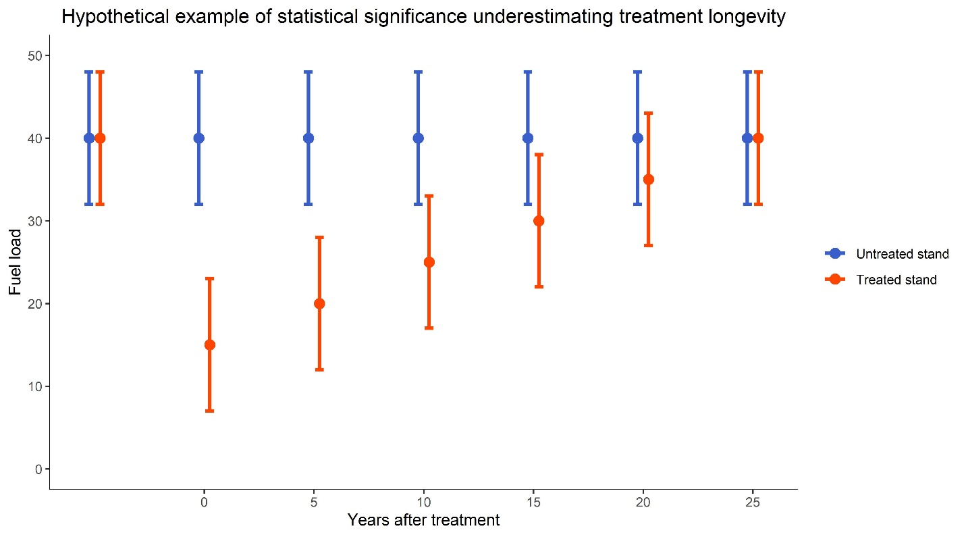used with caution and as one piece in a holistic strategy for thinking about the problem. When asking whether a nonsignificant result is meaningful, it is useful to look at the absolute difference of the estimated means between, for example, a treated and an untreated stand. If the estimated difference between treatment and control or pretreatment and posttreatment would result in meaningful differences in fire behavior or fire management, but confidence intervals overlap, the result should still be taken seriously by managers and policy makers. In scientific terms, such a result would be ecologically significant, but not statistically significant. This means a meaningful difference is likely, but without a large enough sample size to say so confidently. Similarly, two groups can be different in a statistically significant way, but the difference can be small in ecological significance, if the sample size is high enough and/or the variability is low enough (Lieber 1990, Matthews 2019). Additionally, many studies of treatment longevity use permanent plot sampling, so any observed trends are based on revisiting the same plots for sampling in different points in time. In such sampling designs, relatively more trust can be placed in the direction of observed trends, even if not in the mean itself (Bakker et al. 1996, Herben 1996). However, many studies based on permanent plots still rely on significance tests to judge differences between pretreatment and posttreatment fuel loads. Additionally, meta-analytical efforts that combine results of multiple studies, such as our graphs in part 2, can illuminate whether treatments produce similar patterns across multiple studies. Even if many contributing studies produce a statistically insignificant result for a certain treatment/variable combination, consistent patterns across multiple studies can be considered good evidence of a trend, more so than a single study with significant results.

**Factors that affect fuels treatment longevity**

*Site productivity*

Fuel treatment longevity is integrally linked to site productivity, which heavily influences vegetation growth and decay rates, as well as twig and litterfall rates (Jain et al. 2012, Franklin et al. 2018, Harmon et al. 2020). In general, more productive sites will tend to have faster decay rates of dead woody fuel, but also greater rates of litterfall, greater recruitment of ladder fuels, and faster canopy response to openings. Therefore, longevity is likely to be greater on drier sites, shallower soils, and nutrient-poor soils, as well as drier regions. Managers can take advantage of this knowledge, by preferentially treating stands with relatively low productivity to increase average longevity over a landscape, when overall landscape resiliency to fire is the primary goal. Topography was and is a major driver of local-scale vegetation and fuel variability in precolonial and modern forests, with ridgetops and drier south/west facing mountainsides sustaining lower fuel loads, so topography is good starting point for local/landscape scale planning (Hessburg et al. 2015). In areas where high value assets coincide with productive sites, managers will likely need to treat stands often to maintain low fire hazard.

*Treatment type*

Most comparative studies of short-term responses to treatment support thinning followed by burning as the most effective treatment from a fuels-reduction standpoint. Generalities about treatment categories can be misleading because treatments can vary widely in intensity, implementation details, and site context. However, some patterns of short term responses have been established by researchers (Schwilk et al. 2009, Fulé et al. 2012):

* Prescribed burning is generally good at reducing surface fuels, seedling, and saplings in the short term, but often does not change the canopy fuel layer much, besides removing some smaller ladder fuels. Managers are often constrained to conducting prescribed burns in mild fire weather conditions, to minimize risk of escape. More intense prescribed burning may produce more desirable changes in canopy fuels but will be infeasible in most cases.
* Thinning alone is effective at reducing canopy fuels, but can increase short term fire hazard because it moves many twigs and branches to the ground. These excess fuels caused by harvesting are called ‘activity fuels.’ Activity fuels can be addressed by additional measures such as whole tree harvest, mastication, or prescribed burning.
  + Whole tree harvest may be more economically viable than other options in areas with biomass markets. However, it may cause problems for forest nutrient cycling and small animal habitat.
  + Mastication is primarily aimed at increasing decomposition rates of surface fuels, so it could be seen as a strategy for increasing longevity. It is relatively new as a widespread practice, so fire behavior models aren’t well developed for masticated fuelbeds. Research thus far suggests that mastication may result in more smoldering combustion, and that fire behavior can vary widely because of variation in size and shape of masticated pieces (Kreye et al. 2018).
  + Burning after thinning is often preferred where feasible, both because burning most closely mimics natural processes for restoration purposes and because the fuels it consumes are those that would be most available to a wildfire.
* Thinning followed by burning has the triple benefit of large reductions in canopy fuels, established tree regeneration, and surface fuels, including activity fuels. In combination, this could result in greater overall longevity in thinburn units than thin only or burn only units. Within a given set of fire weather parameters, prescribed fire is often more intense in recently thinned units because of the recent movement of twigs and litter to the surface fuel layer, which may result in greater fuel consumption and ladder fuel mortality, but can also cause greater damage to timber value.

Long term responses to different treatment types are less clear, because a very limited number of empirical studies have compared different types of treatments more than five years after implementation.

* In most cases, burning and thinning plus burning units appear to have sustained their fuels reduction benefits into the longterm period compared to pretreatment values. This has included sustained surface fuel reduction, ladder fuel/sapling density reduction, and modelled fire intensity and severity reductions. The differences are not always statistically significant, but multiple studies based on resampling permanent plots support these relative trends (Stephens et al. 2012, Morici 2017, Hood et al. 2020).
* Burning alone and thinning alone do not appear to have the same longevity as thinning and burning in combination, although they often appear to produce statistically insignificant effects in longer term sampling periods
* However, the influx of twigs caused by thinning appears to be short-lived, often decomposing within ten years in both thinned stands (Stephens et al. 2012) and salvage logged stands (Nemens et al. 2019).

Burning alone or in combination with thinning appears to be a more effective fuel treatment than thinning alone (Prichard and Kennedy 2012, Prichard et al. 2020), but because prescribed burn opportunities are severely limited by weather windows, logistical difficulties, resource scarcity, lack of revenue to offset costs, and smoke considerations, thinning alone should be explored further as a possible long term fuel treatment. It is possible that thinning alone may produce greater fuels reduction benefits than burning alone in a longer term than most studies have been conducted. Once the activity fuels decompose, units that are thinned at enough intensity could maintain a lower canopy bulk density, particularly on less productive sites. So in the longrun, thinning could cause a lower rate of litterfall and twigfall to the surface accompanying lower crown fire hazard. Downed twig data from (Morici 2017) and downed twig and canopy bulk density data from (Stephens et al. 2012) support this pattern. Furthermore, while Morici (2017) reports higher downed log and twig loads than pretreatment values 17 years after thinning, the pattern is driven by an increase in rotten logs, with an accompanying decrease in sound logs and twigs. This is consistent with the decomposition explanation. Additionally, when experimental treatments more than a decade old were sampled four years after a beetle outbreak, thinning and thinning plus burning units showed lower surface fuel loads than burning units (Crotteau et al. 2018). These thinned units likely had a lower canopy bulk density at the time of the beetle outbreak, and thus less fuel available to drop from the canopy to the ground. In the longterm, it is possible that burn-only units may not sustain the same level of benefit as thin-only units. Prescribed burns that leave more canopy fuels intact may leave a risk of crown fire in the long run, as well as leaving more litter and twig material to drop to the ground and become surface fuels, in the absence of repeat treatment. Ultimately, the long term fuel dynamics of either thinned or burned stands may be heavily influenced shrub and regeneration response (Tinkham et al. 2016), which may depend on treatment intensity and site productivity as much as treatment type.

*Treatment intensity and productivity*

Treatment types are broad categories that can include a range of intensity (often judged by basal area removal), and different levels of intensity can provoke different responses to treatment. Two crucial aspects of treatment intensity are canopy cover and soil exposure. For both surface fuel loads and canopy cover, there may be an inherent tradeoff between intensity of treatment and longevity of treatment, with a possible optimum somewhere along the intensity gradient. If treatment is not intense enough, it will not change fire behavior. If treatment is too intense, it may stimulate a strong vegetative understory capable of carrying severe fire (Jain et al. 2012).

* Exposed soil is more favorable for recruitment of many tree and shrub species, so heavy surface fuel reductions that expose soil may result in more ladder fuels and live surface fuels in the longterm. Both thinning and burning often expose bare soil. Logging equipment locally displaces and compacts litter and duff with tracks and wheels, and by skidding logs. Prescribed burning can expose large areas of soil by consuming surface fuels, although in many cases it will leave large areas of duff intact, or litter in very mild burning conditions. Fire has the potential additional drawback of stimulating germination for species with heat or smoke activated seeds. These are often shrubs that are adapted to high severity fire and thus produce flammable resin in their leaves, such as several species of *Ceanothus*.
* Likewise, thinning and/or burning projects that open large areas of canopy can stimulate heavy germination of trees and shrubs that can reduce fuels treatment effectiveness in the longrun, in the absence of subsequent treatment. The consequences of open canopy are likely greater on more productive sites, where there is enough moisture for a rapid and dense vegetative response. On drier sites, conditions may be too harsh for heavy tree and shrub regeneration in open patches. In these cases forests may regenerate but at a much slower rate than more productive sites, because the initial successional stages are limited to localized shady or ‘facilitated’ areas (Donato et al. 2012, Rossman et al. 2020). In such sites, it is possible that treatment intensity and longevity are positively correlated.

Grass dominance is also easier to maintain on drier sites. This is often preferable from a fuels perspective, because grass fires have lower flame lengths than shrub or crown fires, so they are less likely to reach into the canopy, and are often easier for fire crews to suppress because it is easier to build a fireline in grasses than shrubs. However, grass fires do have a greater rate of spread. Even on dry sites, several fires in short succession may be required to establish grass dominance. But once grass dominance is established, woody plants have very low regeneration success, and this is likely a desirable state in areas where fuels treatment is a priority (Brown and Sieg 1999).

The lesson for fuels rotation planning is that a productive stand should not receive a heavy fuels treatment without plans to re-treat, because initial treatment could increase the fire hazard over no treatment, through dropping large amounts of canopy fuels to the forest floor and/or stimulating heavy tree and shrub regeneration. It is probably infeasible to simultaneously maintain low surface, understory, and canopy fuels without frequent treatments. This is particularly true on more productive sites where heavy vegetative responses to disturbance are likely. Frequent treatment may be feasible in stands surrounding high value areas such as homes, or in limited areas designated for intensive restoration (Jain et al. 2012). But unless all stakeholders come together to drastically increase the pace and scale of treatments, it will not be feasible to treat large areas of forest on a frequent rotation (North et al. 2012, Kolden 2019).

*Variability*

Thinking about fuels treatments as tools to create forest variability is likely the safest strategy for reducing risk of severe uncontrollable wildfire for the longterm across large landscapes, rather than thinking about reducing fuels uniformly across a treated area. It may be difficult to impossible to treat an area so that it will not have high loads of some fuel component within a relatively short time period, because of the intensity/longevity tradeoffs discussed above. However, fuel loads do not necessarily need to be low to make fire behavior more acceptable for forest management goals; they just need to be discontinuous. Remote sensing, simulation, and historical reconstruction studies have shown evidence that fire severity and intensity are reduced when there is more forest variability, based on metrics like rate of spread and tree mortality. This is true of variability in stand structure within an area as small as an acre, to variability from stand to stand.

In a treatment longevity context, forest managers and researchers could think about creating variability as a strategy for ‘setting the clock’ for different areas to have different loads of different fuel components in different times. For example, managers that cannot burn large areas because of logistical constraints could thin different stands at differing intensities, with the expectation that any given area may have high surface fuel, canopy fuel, or shrub fuel loads, but that none of those types of fuels will be continuous across the area. Strategically important and/or high value locations could be burned at regular intervals, and the discontinuity in the surrounding landscape would likely slow wildfire spread, reduce severity of effects, and reduce the change of an uncontrollable wildfire.

Variability at the local level is just as important. It is likely that frequent fires in precolonial dry forests created a patchwork of canopy openings, individual trees growing alone in openings, and closed-canopy clumps of trees of different tree and clump sizes. The patchwork probably made these forests resilient to contagious disturbances like wildfires and insect and disease outbreaks, because for any given contagious disturbance, susceptible areas were discontinuous. Fires would encounter a patchy structure of different types and amounts of fuels, which kept them from having the uniformly high severity effects that are more common in modern fires (Moore et al. 1999, Larson and Churchill 2012, Franklin and Johnson 2012, Hessburg et al. 2015). Traditional forestry in the United States has focused on producing relatively uniform, optimized forest structure within a stand, based on nonspatial models of stand development (Fahey et al. 2018). However, alternative paradigms and timber marking metrics such as the ‘ICO’ approach (Churchill et al. 2013) have been developing and put into practice in some areas in recent years. Such approaches are likely more viable in restoration treatments than fuels treatments.

In a treatment longevity context, creating forest variability is a critical consideration not only because of the several lines of evidence that variability may reduce wildfire behavior, but also because of uncertainty in both ecological and planning processes:

* From an ecological perspective, our literature review has indicated that there is not enough information about fuels treatment longevity to accurately anticipate the longterm effects of any given treatment on potential wildfire risk. Changing ecological conditions such as climate change and species invasions, and the likelihood of future unexpected social or ecological events, further complicate the uncertainty.
* From a planning perspective, there is uncertainty in future budgets, markets, and administrative procedures, both for private landowners and public agencies. Political or economic events could change the feasibility of implementing fuels treatments overnight, or change what types of treatments are feasible. Therefore, it would be risky to treat a landscape with the assumption that it can be retreated in a certain way at the appropriate time.

Even if there were an optimal solution to the wildfire problem, and our work here suggests that thinning followed by burning is clearly the best supported by current science, it is important to resist the temptation to implement that solution everywhere on the landscape. A broad principle of ecological resilience research states that attempting to optimize any one ecosystem value leaves the entire ecosystem more vulnerable to major, rapid, and irreversible changes, because a more uniform ecosystem has fewer ways of adapting to changes. This becomes catastrophic for communities that grow dependent on one service (Holling and Meffe 1996, Hilderbrand et al. 2005, Franklin et al. 2018). For example, broad areas of even-aged forest managed to maximize profit from timber have proven susceptible to unprecedented beetle outbreaks that harm profits and many other ecosystem values. An example from our review is that that maximizing fuels treatment benefits in the short term may homogenize areas of forest in the longrun, and leave them more susceptible to uncharacteristically large disturbances including wildfire, if rate of retreatment is lower than expected.

Variability could be thought in broad terms not directly related to fuels, and still be useful to for wildfire risk mitigation. Metrics could include different stand structures, successional stages, vegetative communities, and/or different stages of recovery from treatment or disturbance. Use of such metrics should be paired with informed expectations about fire behavior implications, which can be informed by research. Which metrics of variability are most useful will depend on local ecological context, and which goals other than fire management are most important to the landowner. Managers will likely need to use broad metrics to understand fuel load and variability in the areas under their jurisdictions while relying on researchers to help inform expectations about the fuels implications, because collecting adequate data on fuels from many stands over a large area would be prohibitively expensive.

Collecting and synthesizing information to reduce some of the uncertainties highlighted above was a major component of this project, and our work has provided insights that should help managers, researchers, and policy makers plan to increase forest resiliency in eastern Washington. In this introductory section and the discussion below, we discuss the long-term outcomes we believe are most likely based on a range of factors. But we caution that most of our judgements should only be treated as hypotheses, given the evidence available.

**Part 2: Data on Treatment Longevity**

In addition to the treatment longevity review above, our team was funded by the Washington State Legislature to complete three tasks:

1. Compile datasets that could be leveraged to answer questions about treatment longevity and long-term fuels dynamics, including ready-for-analysis datasets and datasets requiring resampling to get long-term data.
2. Collect field data to build on existing datasets from in stage one.
3. Synthesize fuels information from tasks one and two, and report on the state of knowledge in fuels treatment longevity.

For task 1, we contacted 54 managers and fire researchers across multiple government agencies, universities, tribes, and nonprofits. For us to use a dataset in this report, the dataset needed to:

* Include numerical data on surface fuels such as twigs, litter, and duff, which are critical elements for predicting surface fire behavior.
* Have data on treatment effects at least ten years after treatment.
* Focus on dry, historically frequent fire forest types.

Out of more than 20 datasets we learned about in this manner, we found three datasets that we could use to address the goals of this report.

* The ‘Colville Chronosequence’, a dataset for which the Colville National Forest sampled different stands at different times since treatments to look for time-since-treatment trends in fuels and vegetation. Most study stands were thin plus burn treatments, so we focused only on this treatment type. This dataset was the best suited for looking at time since treatment, because many points in time were represented. But chronosequence studies need to be used with caution, because it is possible to confuse spatial variation for variation in time.
* The ‘Mission Creek’ site of the Fire and Fire Surrogates study, an experimental comparison of burning, thinning, thinning plus burning, and control units, which was being resampled about 15 years after treatment. This dataset was the best suited for comparing longterm effects of different treatments, but will fail to detect any important thresholds in fuel accumulation with time because the ‘long-term’ period was only represented by one temporal ‘snapshot’.
* The ‘NPS Fire Effects’ dataset, a National Park Service treatment monitoring program at the North Cascades and Lake Roosevelt National Recreation areas, for which we focused on thinning and burning units. Because of frequent retreatments, this dataset was best suited for looking at interactions of different combinations of treatments with high temporal resolution. It did, however, contain 22 plots that were either thinned and burned, or burned, thinned and burned, and that were monitored at a relatively high temporal resolution for 15 years.

For task 2, we collected field data to augment the Colville Chronosequence and Mission Creek datasets, which best addressed our questions of interest and which would benefit from a larger sample size increasing statistical power. We collected 112 plots at Mission Creek and 42 plots on the Colville National Forest.

For task 3, we aggregated data from these Washington datasets along with published data from other dry forest datasets around the western US, into ‘meta-analysis’ scatterplots comparing key fuels variables against time since treatment. For the purposes of this report, we limited the scope of studies to be included in our metanalytical graphs, to fuels-based studies of dry, frequent forest types relevant to eastern Washington (ponderosa pine/yellow pines or dry mixed conifer). Studies had to include information on surface fuels at least five years after a treatment. We did not include analyses of natural disturbances like wildfire or beetle outbreaks, or retrospective studies of treatment performance in real wildfires. We chose to analyze three treatments: burn, thin, and thinburn, because these had by far the greatest number of studies addressing longevity questions, although single studies are available for exploring other treatments like multiple burns, or mastication. For this report, therefore, we address only a portion of the complicated issue of fuels treatment longevity. Our work on treatment longevity is ongoing, however, and we have plans to incorporate additional opportunities into our future work.

We chose to look at a few key fuels and stand structure variables that are commonly reported in fire ecology studies. Some important variables such as shrub composition, cover, and biomass are often unreported in fuels studies and/or published in separate accounts; therefore we did not include them in the current report. We also did not include modelled fire behavior because of different model parameterization in different studies. We did not include studies that lumped all surface fuels categories into one group. We plan to address these components of treatment longevity in more detail in future work, as we expand the scope of this project. For this report, the variables we included are:

* Surface fuels: twigs and forest floor.
* Canopy fuels: canopy base height and canopy density.
* Stand structure: basal area, density, and quadratic mean diameter.

These variables were not all reported in all studies we used, so sample size varies by fuels component. Since we focused on studies using surface fuels, our sample shows a bias towards higher sample size of those fuel components. Canopy fuels, for example, are relatively underreported in our sample. Additionally, we had to lump some components that can cause different fire behaviors because of lumping in some studies. Specifically, we aggregated twig data across multiple size classes and aggregated litter data with duff data. This is a limitation of the existing fuels literature. For example, duff and litter affect fire behavior very differently unless fire weather is extreme. Litter tends to burn and duff instead smolders if it combusts at all, unless conditions are very dry. So litter contributes more to flame length and rate of spread, while duff smoldering can expose tree roots to sustained heat and thus cause tree mortality, and create challenges in the ‘mopping up’ stage of fire suppression. Many studies aggregate these and other variables in reporting, but we advocate for thorough reporting of all fuels components in future studies, to allow for more nuance in synthesis projects such as this one.

Our metanalytical graphs are best approached as a tool for generating hypotheses and exposing research gaps in treatment longevity, and not as a means for drawing solid conclusions. There are many confounding factors that could lead to erroneous conclusions, including differences in region, forest type, sample size, sample protocol, and details of treatments between studies. We have chosen to present graphs with a complicated scheme of panels, shapes, and colors, to convey the message that this body of this type of knowledge on fuels treatment longevity has complexities that make it difficult to synthesize into clear messages, and to inform the hypotheses we formulate. Because of the many potentially confounding factors, any of these hypotheses we draw from the meta-analytical portion of our work will need to be tested empirically before they are treated as fact.

Additionally, we chose not to rely on any statistical testing, for the reasons discussed in the introduction above. Instead, we used visual analysis of the graphs, which we believe stimulates more critical thought about the data, but which also may give more space for our biases. We believe that stepping back from statistical significance is an important exercise at this point in the development of fuels treatment longevity research, and that our doing so adds fresh perspective. However, this is another reason that our conclusions are best treated as hypotheses, rather than facts.

Despite all these caveats, our meta-analysis graphs show strong evidence of convergence in patterns of longterm response for some variable/treatment combinations, which should prove useful to managers, landowners, and policy makers in western dry forests.

**Metaanalytical Graphs**

*Surface fuels: twigs, and litter and duff*

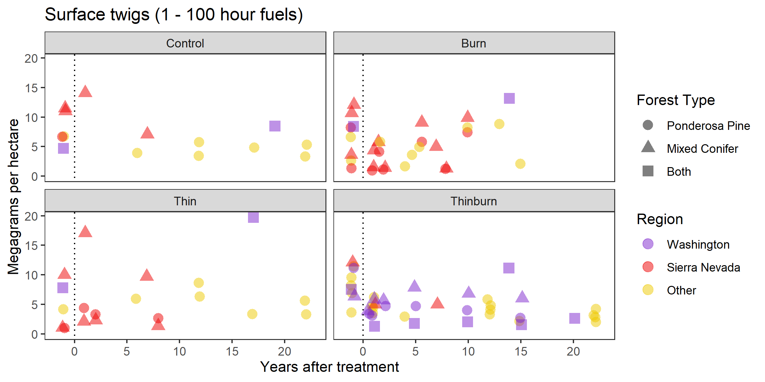

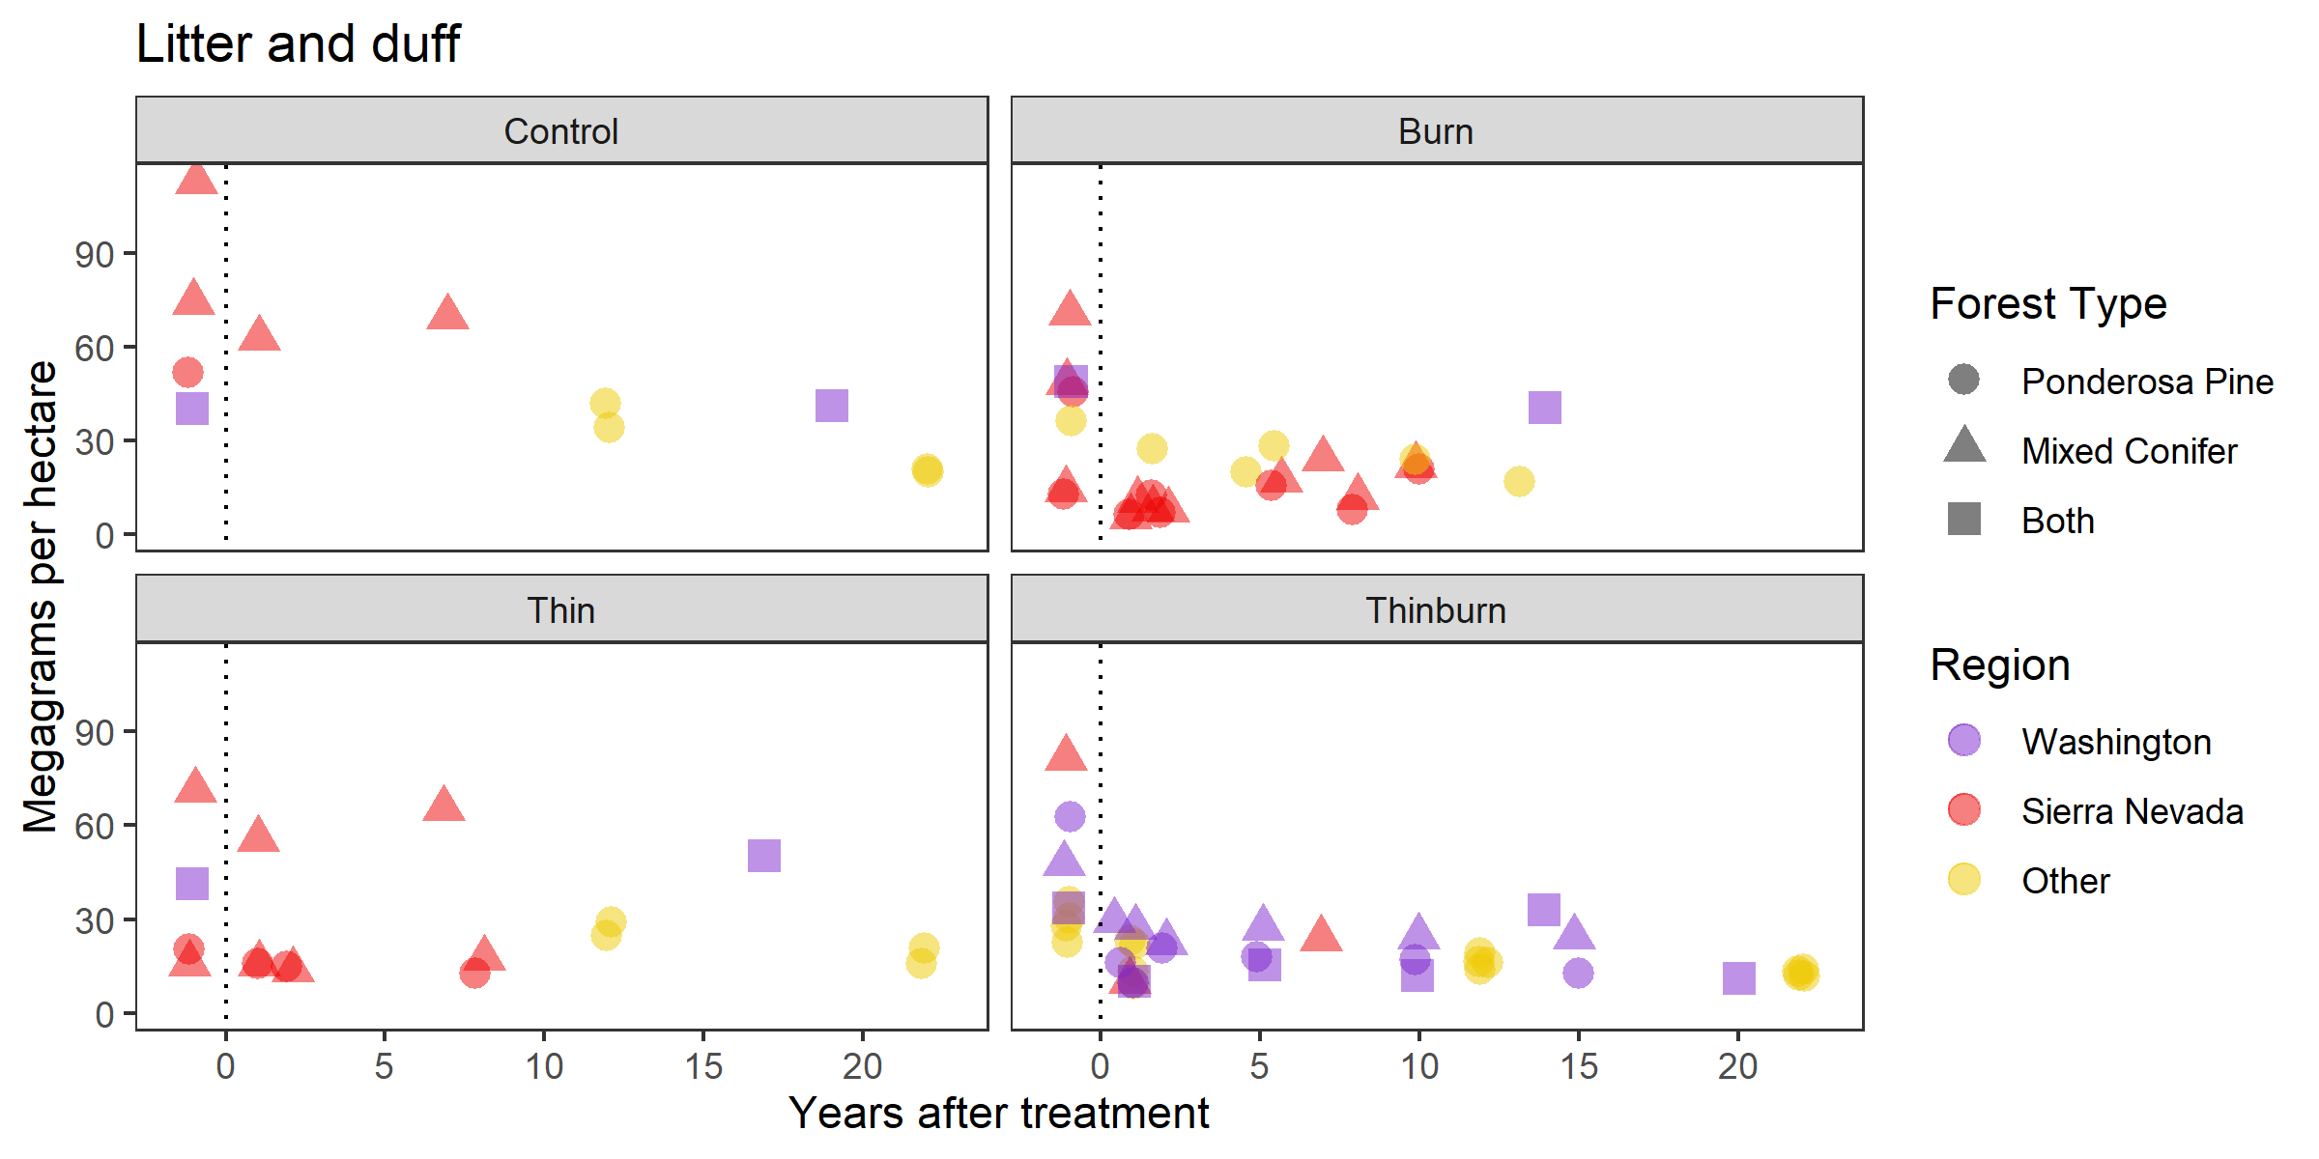

*Canopy fuels: canopy bulk density, canopy base height*

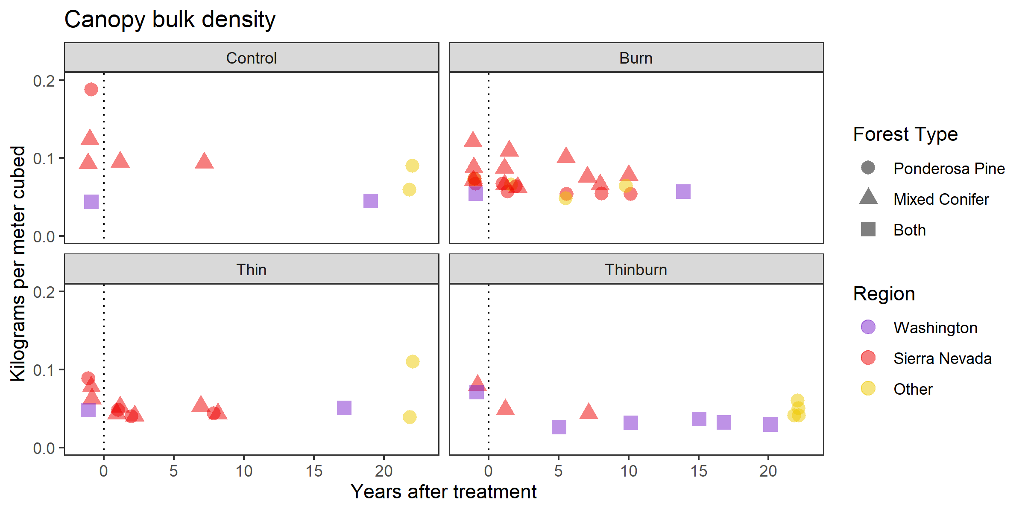

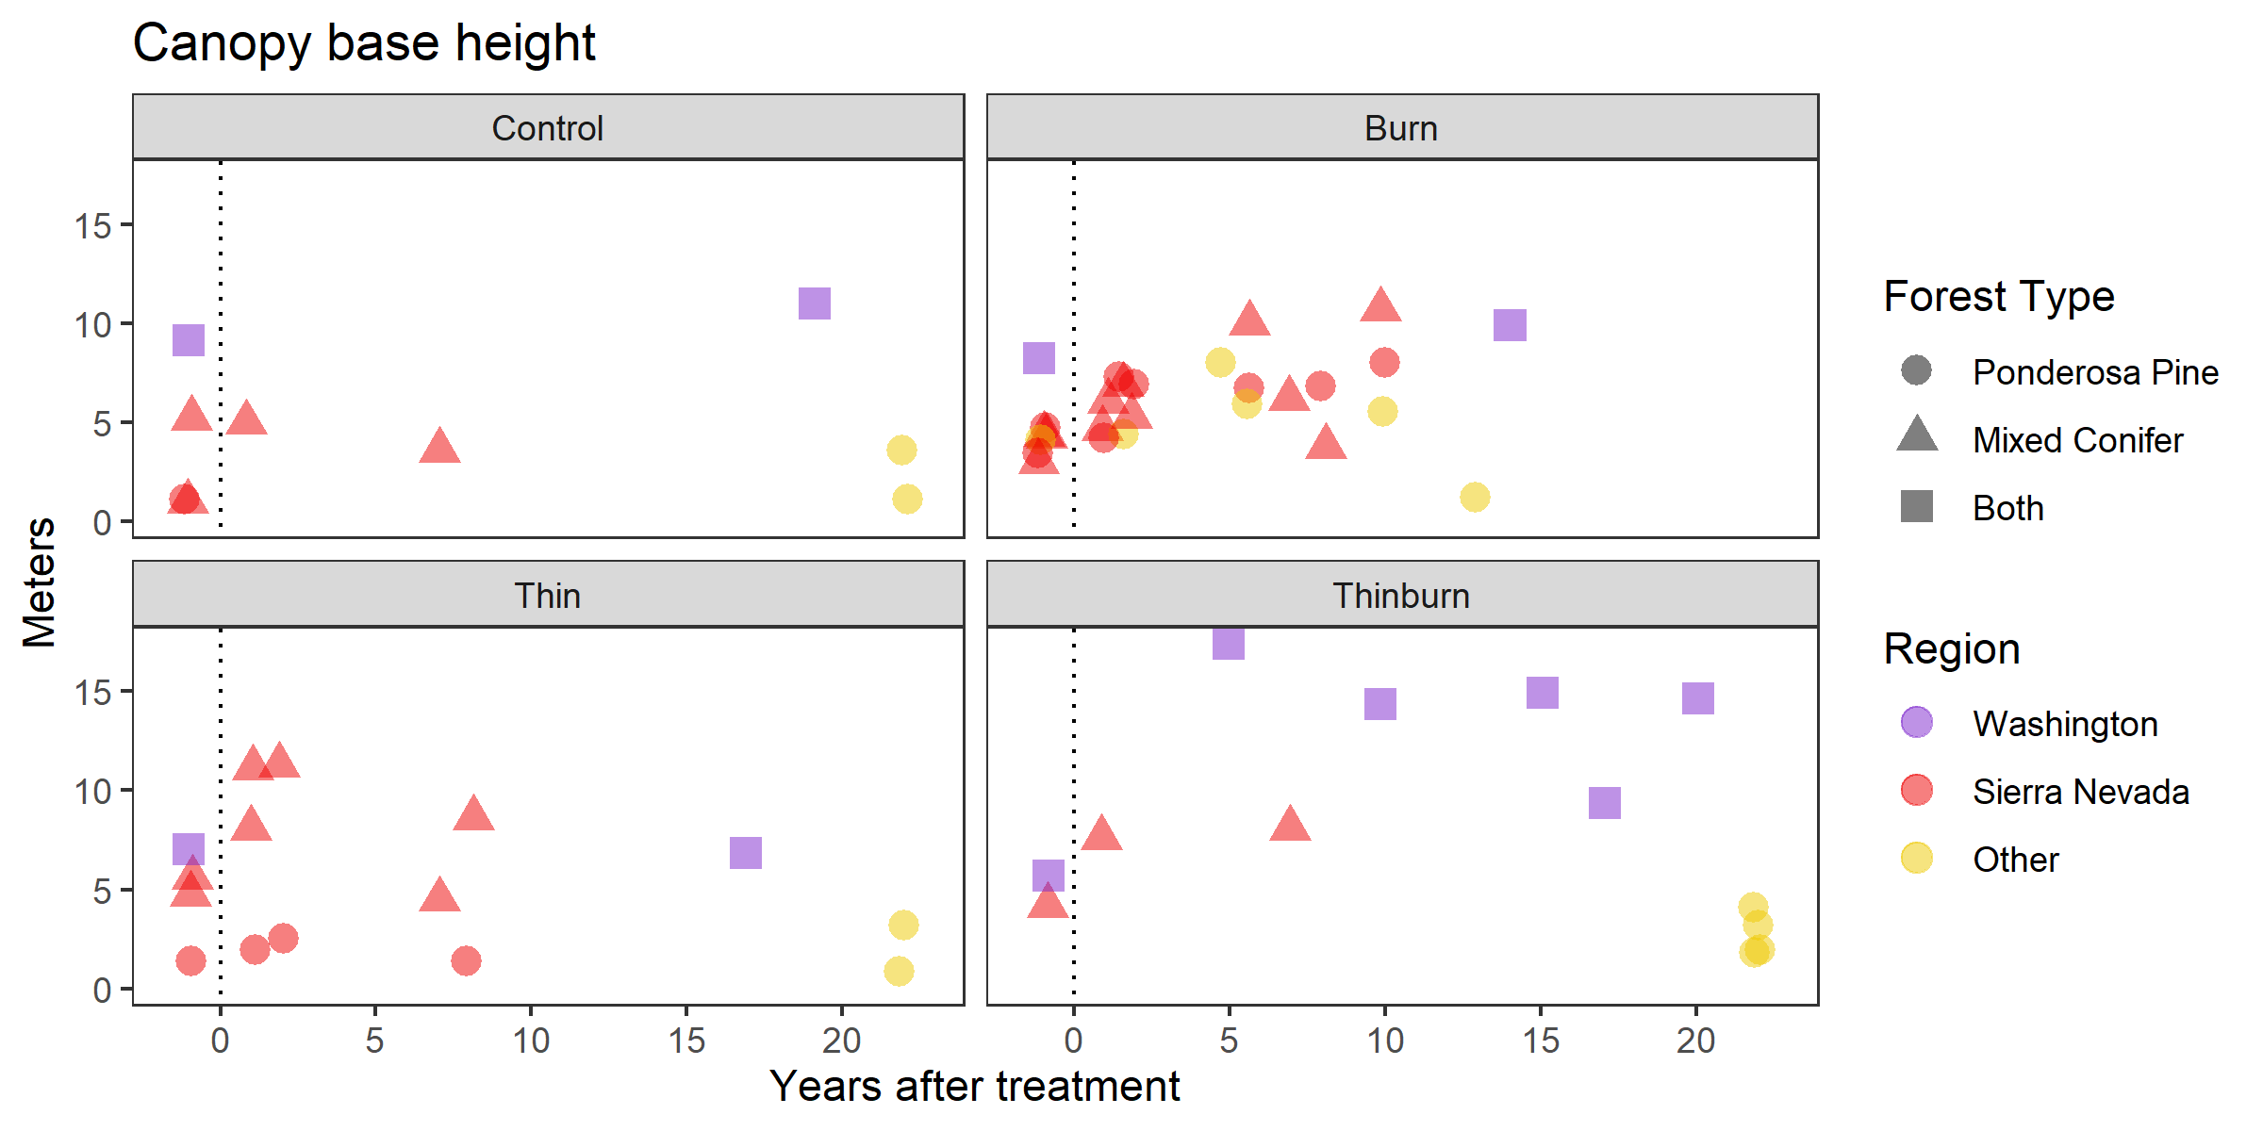

*Stand Structure*

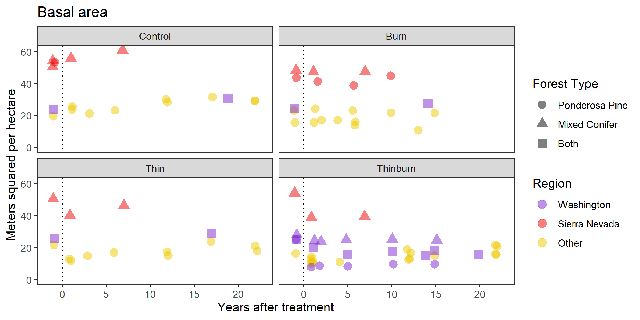

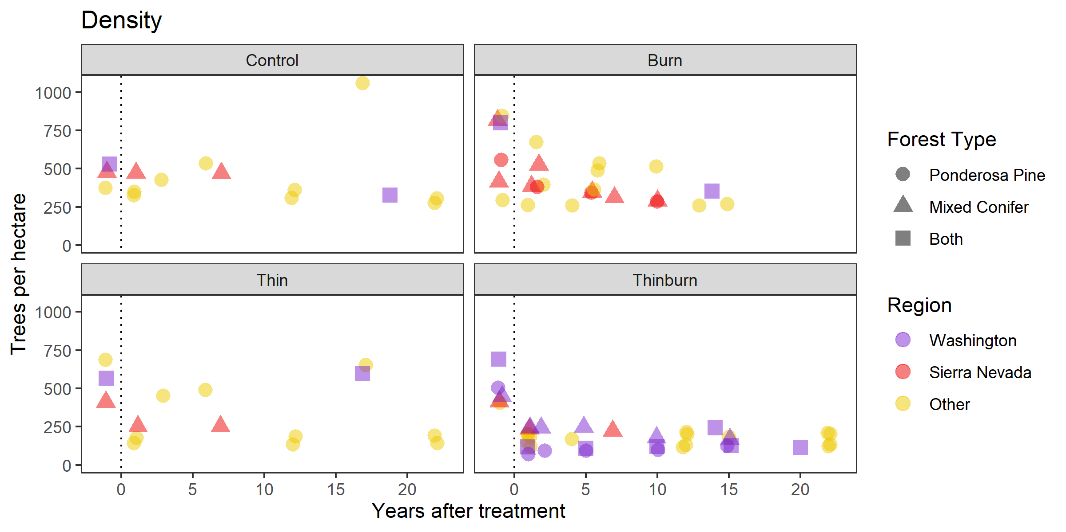

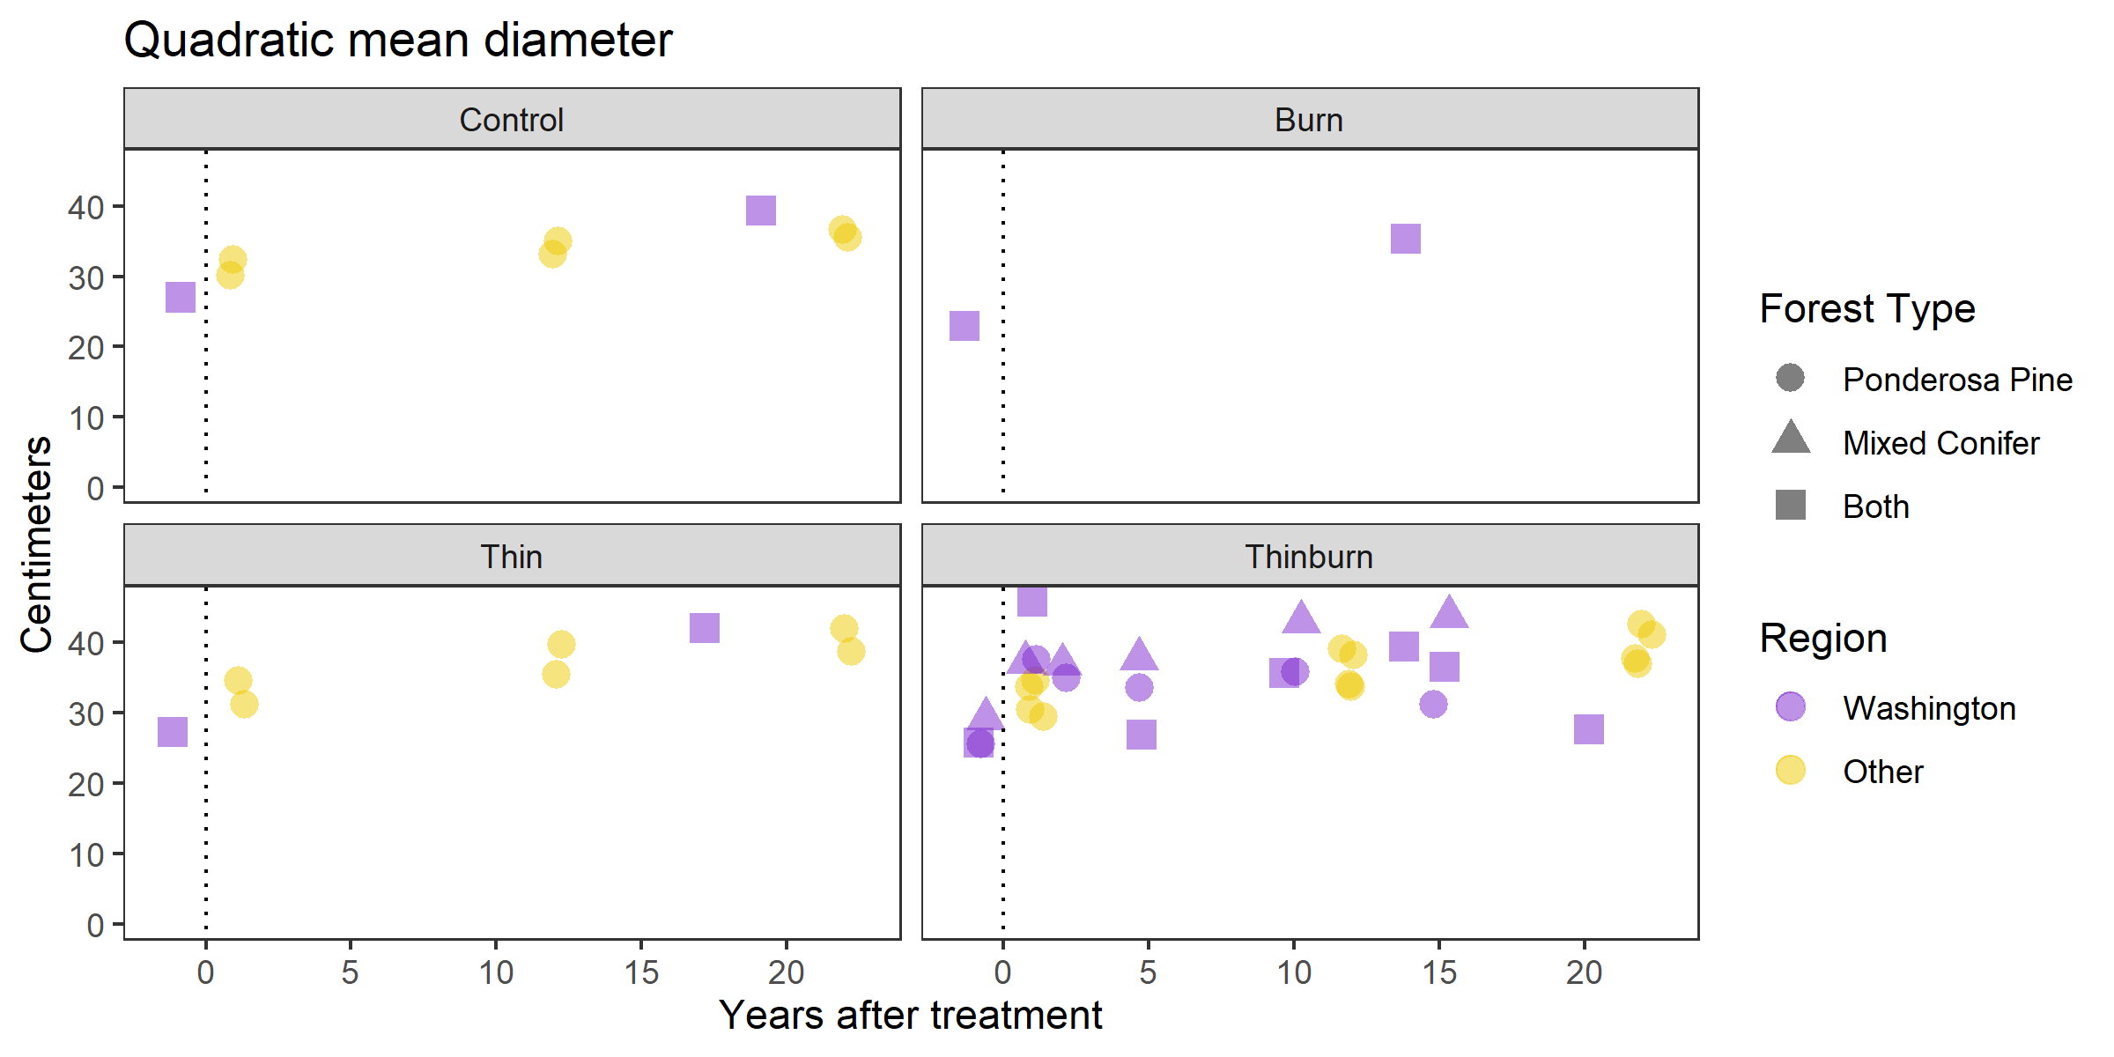

**Results and Discussion**

Fuels and restoration treatment longevity is a critical question for dry forest management of the western US, and our data collection and synthesis has suggested some general trends in longterm fuels dynamics and revealed research needs.

*Treatment type*

Our work strongly suggests that thinning followed by prescribed burning has the greatest longevity of the treatments we looked at, for surface fuels, canopy fuels, and stand structure. Thinning and burning effectively addresses surface fuels, canopy fuels, and regeneration in a short time period. Tree density reduction is sustained for at least twenty years, and basal area recovery appears to be slower than other treatments. This suggests lower canopy recruitment than other treatments, which may contribute to the sustained reductions in surface fuels, particularly litter and duff. Data on surface twigs suggest a short-term spike in the five-ten year range, suggestive of delayed tree mortality in the fire, followed by decreases that suggest decreased rates of twigfall from the canopy. A similar process happens in thin units, but in a shorter time since treatment window, and in burn units, but to a greater magnitude and with less evidence of a long-term decline.

Burning alone appears highly effective at removing surface fuels in the short term, but in the long run can either drop fine fuels from the canopy if it kills overstory trees, or have little influence on the canopy if it does not. Neither case is desirable for restoration and fuels treatments. Our data suggests delayed tree and canopy mortality and/or delayed twigfall; fine surface twigs in burn units recover to pretreatment levels within about ten years, but reductions in litter in duff appear more sustained. In most cases these are accompanied with gradual reductions of canopy bulk density and tree density, along with gradual increases in canopy base height. This suggests that repeat burning may be an effective strategy for sustained fuels reductions, because, similar to thin and burn treatments, repeat burning could transfer canopy fuels to the ground, and then remove them once there. However, burning may have modest impacts on longterm canopy fuel loads and litterfall rates, judging by its small impact on basal area and canopy bulk density. Both thin and thinburn treatments appear to produce temporary increases in surface fuels followed by either a return to a similar equilibrium (thin), or a consistently lower fuel load in the long term (thinburn). In our analysis burn treatments do not show a similar return to some twigfall equilibrium, perhaps because of the combination of delayed surface fuel influx caused by burning and the relatively small sample of longer-term burn data in our analysis. It does seem to produce a relatively sustained reduction in litter and duff however, with modest recovery in more productive forest types.

Thinning alone appears to have less longevity in its effects on fuels variables in general, both for the influx of surface fuels and the reduction in canopy fuels that have been widely observed in short term studies. Thinning is effective at removing medium to large sized trees, but often many seedlings and saplings survive the treatment. These established trees are poised to take advantage of the additional light, and less likely than new germinants to be outcompeted by grasses and/or shrubs. In our graphs, canopy base height and tree density both appear to recover quickly in thinning treatments relative to those containing a burn, offering indirect evidence that surviving small trees may be reducing longevity of thinning treatments. Surface twig data support this hypothesis too; within contributing studies there appears to be a consistent short term spike in twigs followed by a decrease to levels roughly equivalent to pretreatment values. The length of the return to ‘normal’ appears dependent on forest productivity, which is strongly correlated with decomposition rates. It appears that long-term twig values do not go well below the pretreatment value in comparison with the magnitude of the short-term increase. This suggests the long-term rate of twigfall isn’t dramatically changed by thinning, possibly because of infilling by advanced regeneration. Thinning alone unfortunately appears to be a poor strategy for fuels management in both the short term and long term. However, our basal area data suggest that the thinning treatments in our study were of relatively low intensity, removing well less than half the basal area in cases with a pretreatment read and short term read. It is possible that more intensive thinning can lead to more desirable long-term effects.

Fuel dynamics in untreated stands are important for contextualizing long-term dynamics in treated areas, and in weighing relative benefits of retreatments and new treatments. Untreated stands appear to have moderately declining litter and duff loads, consistent canopy bulk density, and increasing basal area and tree size over time, although sample size is relatively low. The increase in basal area and decrease in tree density is commonly observed in middle successional stands. The impacts of these processes on fine surface fuels are not well understood, but canopy gaps are expected to become more common as forests age (Franklin et al. 2018), which could result in more patches where surface fuel builds after adjacent mortality and then decreases to a lower equilibrium after decompositions. Climate change could also be a driver of changes in surface fuels; it is possible that trees are producing fewer leaves as growing seasons become warmer and drier. This would not be captured well by the canopy bulk density estimation procedures used in fuels studies, which rely on trees’ total height and live crown base height to determine canopy density based on relationships established in more intensive studies. Alternatively or additionally, it is possible that warmer weather in relatively cold and wet shoulder seasons is allowing for more decomposition, thus altering the equilibrium between litterfall and decay. Either of these climate change driven processes could cause researchers to confuse the effects of climate change with the effects of treatment. Litter and duff do appear to be declining over time in most treatments we analyzed, although not ubiquitously.

**Productivity**

Our work suggests that forest productivity contributes to absolute fuel loads, and in a few cases affects rate of response of some variables to treatment. From our graphs, productivity can be roughly judged on multiple scales. On a regional scale, the Sierra Nevada region is relatively more productive than the other regions, and within a region, the mixed conifer type is more productive than ponderosa pine. This method does not capture productivity variation within a single landscape, which should be judged from results of individual studies. It is possible that our comparisons of broad productivity categories may reveal different patterns than those driven by productivity variation on an single landscape, so managers should approach our productivity results with caution. It is also hard to judge long-term effects of interregional productivity variation from our graphs, because studies of the Sierra Nevada haven’t extended as long after treatment as some studies in Washington and other parts of the interior west, although some clues can be gained from patterns within ten years.

Productivity appears to affect absolute fuel amounts more than rate of recovery from treatment. More productive forests have higher basal area and canopy bulk density, and these differences are often sustained after treatments, particularly for basal area. The relationship of productivity with surface fuels appears more ambiguous, perhaps due to variable interactions between decay rate and litter and twigfall rate, all of which are likely to be greater in more productive forests. Surface twig patterns after thinning suggest a strong effect of productivity on decay rate. Productivity likely affects longevity through its effects on regeneration rates, and our graphs do hint at faster canopy base height recovery in more productive forests. However, our data appears not to cover the time period necessary for regeneration to have conclusive effects on metrics like density or canopy base height, particularly for short-studied Sierra Nevada forests. We expect that longer term studies will illustrate lower longevity of regeneration dependent metrics in more productive forests.

**Deep dive: NPS data**

NPS has 22 plots tracked to 15 years at fairly high temporal resolution, and I want to use the data for a deep dive into twig, litterduff, basal area, and density patterns. Unfortunately they didn’t do canopy base height until recent years, so we don’t get to explore canopy fuel. The biggest lesson here for me is nonlinear dynamics in the twig data, this could cause a lot of misunderstandings about treatment longevity in other studies:

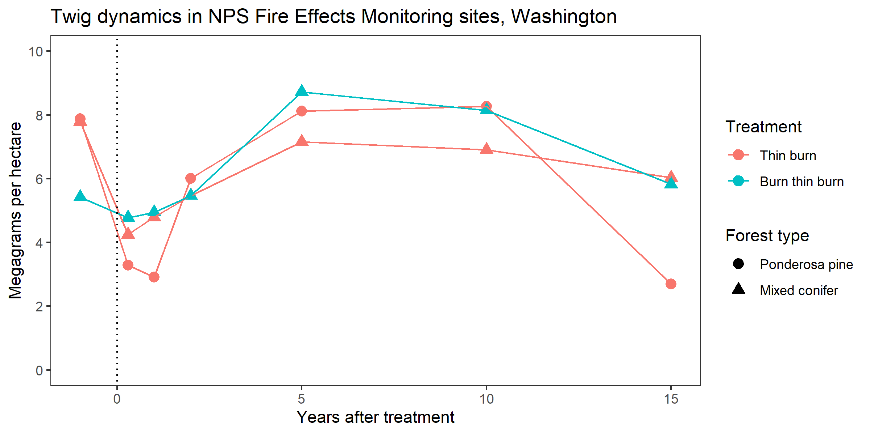

**Conclusions**

Our takeaway points are based on a small sample of fuels-based studies using variable protocols in variable regions, so they should be used with caution and compared with local monitoring when possible. Further research will help refine our understanding of longevity, and may change these ‘rules of thumb’. However, our meta-analytical graphs are suggestive of many patterns, strongly suggestive in some cases and more weakly in others. Our takeaway points are bulleted below.

*Treatment longevity estimates*

Based on these graphs, our best estimates are longevity of different treatment types are:

* At least 20 years for thinning in combination and burning.
* Around 10 years for low intensity burning, with longer effects on litter and duff.
* No effective time range for low intensity thinning, because of surface fuel elevation in the short term and return of canopy fuel in the longterm.

Key lessons for individual fuels components include:

* Twigs will fall to the ground and become surface fuels regardless of treatment, but the effect is more delayed following a burn treatment than a thin treatment, and less pronounced in thin plus burn treatments. Thinning brings a sudden, short term influxes of twigs that decays at a rate dependent on site productivity: less than ten years for Sierra Nevada mixed conifer forests, around twenty years for interior ponderosa pine forests. After a thin burn treatment, twigs loads steadily build to around ten years after treatment, and then fall until at least fifteen years after treatment, perhaps towards a new, lower equilibrium between twigfall and decay rate. The rate of this pattern appears somewhat independent of site productivity. A similar pattern is seen in burning treatments, although there aren’t enough datapoints in the decade plus range to be as confident in a new, lower equilibrium.
* Litter and duff sustain long-term reductions in burn units, whether burning only or thinning and burning. These reductions appear to last longer than 15 years. Thinning reduces litter and duff in the short term, but it appears to recover in less than ten years. Untreated stands seem to be losing litter and duff over time, but the sample size is low.
* Canopy fuel loads and forest structure do not sustain large, longterm changes in any of the examined treatments except for thinburn. It is likely that more intense thinning only or burning only treatments may have different results.
* Ladder fuels appear to recover in less than ten years in thin only and burn only units, judging by the rough proxy of canopy base height, although there is less evidence of density recovery in burning than thinning.

Lessons for forest productivity include:

* More productive forests likely have higher absolute canopy fuel loads, judging by basal area and canopy bulk density. Therefore, more productive sites are probably more likely to experience severe crown fire than less productive sites .
* Surface fuels show a variable relationship with forest productivity, likely because of variable interactions between decay rate and litter/twigfall.
* Post-treatment recovery rate and patterns are surprisingly independent of forest productivity for most metrics and treatment combinations.
* Our analysis facilitated analysis of productivity gradients at broad scales, and it is possible that lessons learned here don’t apply to productivity gradients within a single stand or landscape, which is the scale managers operate at.

Lesson for research needs include:

* More data on longer term responses. Data on fuels components more than a decade after treatment are still sparse, particularly for productive Sierra Nevada forests, and the patterns we highlight here need to be considered more hypotheses than facts. Additionally, very few data extend more than twenty years after treatment, so the full lifecycle of analyzed treatments in unknown. This is particularly true of thinburn treatments, which appear to sustain treatment benefits to at least twenty years beyond treatment. Understanding longterm and very longterm patterns will have important implications for deciding whether to implement new treatments or maintenance treatments.
* Data from more treatment types, variations, and combinations. We looked at only three treatments that had enough replication to meet our criteria, but many other practices are available to managers who want to reduce fuels. Methods we didn’t analyze include pileburning, repeat burning, repeat thinning, mastication (although included in some Vaillant study sites), herbicides, browsing, clearcutting, or natural disturbances. We plan to include natural disturbances like wildfire and beetle outbreaks in future longevity work, but in many other cases there aren’t enough data for a synthesis such as this one.
* Data on more variables. Many fuels-relevant variables go unreported or unsampled in fuels studies, as is shown by the absence of regeneration, shrub, and grass data in our analysis, and by the relative sparsity of canopy fuel data compared to surface fuel and stand structure data. This likely gives our analysis an incomplete view of the fuels treatment longevity. In some cases, such as regeneration and shrubs, patterns have been studied in separate publications from fuels. We did not include data from non-fuels studies in our meta-analysis for this report, due to the time requirements necessary to thoroughly search a separate body of scientific literature, but we plan to do so in our future work. Many studies also lump variables such as litter and duff, or different sizes of woody fuels, that drive different wildfire behaviors. We recommend that scientists studying treatment longevity report all the variables feasible, to the resolution feasible, to facilitate more complete synthesis efforts.
* Data on more intense treatments, and on intensity gradients within studies. Our findings appear to contradict the intensity/longevity tradeoffs hypothesis, in that thinning and burning is the most intense treatment and the one with the highest longevity. This is based, however, on a relatively small gradient of low average treatment intensity. Additionally, our graphs do not directly address shrub, grass, and regeneration patterns, which are an important component of the hypothesis. Field studies are best suited to investigate treatment intensity tradeoffs, as they can explore patterns between plots and between stands, rather than looking at broad treatment averages as we have in this report. Whether the treatment/longevity hypothesis is true or not has major implications for management decisions revolving around longevity, so researchers should include analysis of this question where feasible.

This report is a relatively early stage in the development of our work on treatment longevity, which is largely based around Don’s dissertation. We will continue expanding the scope of this review and developing our ideas, until it is ready for peer-reviewed publication. We will also work on empirical studies of the Mission Creek, Colville Chronosequence, and NPS Fire Effects datasets in Washington state, which will each allow us to explore and test unique aspects of fuels treatment longevity in more detail than is feasible in this report. We look forward continuing our exploration of this complicated and important issue.

**Acknowledgements**

We would like to thank the members of the Washington Treatment Longevity Project team who helped us in phase 1 of this project: Kate Williams, Jon Bakker, Ernesto Alvarado, and Dave W. Peterson, and all the managers and scientists who responded to our requests for information. We’re indebted to the crewmembers that helped us with fieldwork and data processing during the difficult season of 2020, including Marwa Mahmoud, Marcela Todd, Michael McNorvell, Maddy Stone, Sienna Patton, Allison Phillips, Jane Wynne, Skylar Bueche, Paige Byassee, and Sam Tharpgeorge. Mission Creek collaborators thus far have included Jon Bakker, Ernesto Alvarado, Madison Laughlin, and Dave W Peterson. Monique Wynecoop, Eric Pfeifer, James Pass, Jason Jimenez, Kate Williams, and Jason Clark all helped with finding the Colville Chronosequence data and designing our resampling effort. Karen Kopper is collaborating with our work on the NPS fire effects monitoring dataset, has supervised data collection in recent years, and provided us with the data. Daniel Wagner with the Forest Vegetation Simulator program was very responsive and helpful with our FVS questions. Michelle Agne gave us valuable feedback on earlier drafts of this report, that improved the quality of the content and flow.

**Appendix One: Deliverable description**

All deliverables are stored in a Box.com workspace named DNR restoration needs, with shared access by Don, Brian, and Derek, in the washington_treatment_longevity_project folder.

Task 1 and 2 deliverables consist primarily of tabular data in .csv form, spatial data stored as shapefiles, and supporting information. Deliverables for task one were completed by March 14th, 2020 and presented to DNR staff on March 18th, 2020. Deliverables for task two were completed by November 14th, 2020 and presented to DNR staff on November 20th, 2020. The two tasks are stored together, since they both consist of data collected with the same protocols per project. For the three main projects used in this report, data can be found in ‘washington_treatment_longevity_project/task_one_and_two_deliverables/three_main_datasets.’ Each project is contained in a folder labelled by its name, with summarized data in .csv form in the ‘data’ folder. Additionally, each project contains a ‘gis’ folder for spatial information, and a ‘radcliffe_workspace’ folder, with Don’s full GitHub workspace for each project, which contains data in more raw format, R scripts and markdown files, graphs, supporting information, and other files that Don has generated or used as of June 29th, 2021. Any scripts or outputs outside of the ‘data’ folder should be considered works in progress, and potential users should check with Don for any updates before conducting analyses. Any information Don collected from projects other than the three main projects is in the ‘otherProjects’ folder, and this varies by individual project based on the types of files that were shared with Don.

Deliverables for task three consist of this report, and of the data compiled for the meta-analysis graphs. They were completed and presented to DNR staff on June 30th, 2021. These are contained in the ‘washington_treatment_longevity_project/task_three_deliverables’ folder. The ‘data’ folder contains the .csv file that forms the basis of the meta-analytical graphs. The ‘radcliffe_workspace’ folder contains Don’s Github workspace for the meta-analytical graphs, with R scripts for creating the graphs, saved images of published figures from which data were digitized, and saved images of the graphs produced. The ‘report’ folder contains this report.

**Appendix Two: Detailed information about Task 1 – 3 of the DNR Treatment Longevity Project.**

*Task One*

In the winter and spring of 2020, Don Radcliffe of the University of Washington (UW) compiled a list of fuels treatment studies in Washington State with monumented plots to explore study options for his PhD dissertation. He collaborated with Derek, Brian, Kate Williams (DNR), Jon Bakker (UW), Ernesto Alvarado (UW), and Dave W. Peterson (USFS), who helped him contact 54 fire ecologists who have worked in Washington, 37 of whom responded. The project, named here the Washington Treatment Longevity Project (WTLP), was funded by the Washington State legislature. The intent was to inform the DNR 20 Year Forest Health Strategic Plan. The team’s immediate goal was to find datasets with pretreatment data, that could be resampled in the summer of 2020 to gain information on the long-term effects (10+ years) of fuels treatments. They were interested in several response variables, including fuels, shrubs, merchantable timber, and/or tree regeneration. However, fuels data was a prerequisite to being included in the list. The datasets most relevant to these goals included the Mission Creek Fire and Fire Surrogates Study, the National Park Service Fire Effects Monitoring Project, and the Colville National Forest Collaborative Forest Landscape Restoration Project. Two other notable projects that may provide data relevant to fuels treatment longevity in the future are: the DNR Forest Resiliency Burn Pilot, and the Sinlahekin Fuels Monitoring Project.

The Mission Creek Fire and Fire Surrogates Study (FFS) is a long-term interdisciplinary experiment testing the effects of thinning, broadcast burning, and thinning plus burning on a range of response variables. It is located in the Wenatchee Mountains near Leavenworth. Twelve units were established in the early 2000’s and treated in 2002-2006, three each of control, thinning, burning, and thinning plus burning. Pretreatment sampling took place in 2000, and posttreatment data was collected partially in 2004 and partially in 2006. In 2012, the Poison Creek wildfire burned two of the control units, one burn, and one thin unit. In 2019, Don led a crew that sampled fuels in the 8 units that had not been burned in a wildfire. They only resampled plots for which a plot monument was relocated (137). After preliminary statistical analysis and exploration of datasets that could address long term effects of fuels treatments, the Washington Treatment Longevity Project team decided that the FFS merited sampling of the plots for which a physical monument could not be found, and the plots that burned in the 2012 wildfire. This will give Don needed statistical power to explore dynamics of fuels loadings and heterogeneity in different treatments 15-20 years after treatment, and to compare the effects of treatments to the effects of wildfire. Don, Brian, Derek, Jon, Dave, and Ernesto are collaborating on analyzing the data and producing a publication as a part of Don’s dissertation work. Other short-term data that could be leveraged to explore long term responses include sampling of trees, birds, small mammals, and soil. Understory vegetation was analyzed and published by a team including Jon and Dave (Rossman et al. 2018), and the same team has produced a publication on tree regeneration (Rossman et al. 2020). Additionally, the Washington LiDAR portal indicates that LiDAR flights have been conducted over the entirety of the study area, a portion in 2015 and a portion in 2017.

The National Park Service Fire Effects Monitoring project (NPSFX) includes monitoring of various combinations of thinning, broadcast burning, and pile burning dating back to 1996, on 155 monumented plots. There are two sites, the Stehekin area of North Cascades National Recreation Area, and the Lake Roosevelt National Recreation Area. Karen Kopper, Fire Ecologist with the National Park Service (NPS), was the team’s main contact for this dataset. The NPS employs a seasonal crew that spends a portion of each summer sampling a subset of the plots. They resample plots 0, 1, 2, 5, 10, and 15 years after the most recent treatment. In total, there have been more than 600 plot reads. The project started with a small number of monitoring plots, and has added new plots in new units nearly every year since inception. Don, Karen, and Brian have agreed to collaborate on analyzing the data and producing a publication, as a part of Don’s dissertation work. No WTLP team fieldwork will be required. The main question of interest will be how the rate of fuels accumulation varies with different treatment and retreatment combinations. There is data to produce publications on other response variables, including dynamics of trees, shrubs, and herbaceous vegetation.

The Colville National Forest Collaborative Forest Landscape Restoration Project (CFLRP) included monitoring of about 150 plots in 2013, including pretreatment reads in two project areas (East Wedge and Walker), and a ‘past treatments’ chronosequence study of commercial thinning, shelterwood cuts, and clearcuts, some of which were burned at various numbers of years after the timber sale. The past treatments portion of the study included units treated up to 20 years prior to sampling. The main contact for information on the monitoring data is Jason Clark, who led the field crews in 2013. He is currently at the University of Alaska – Fairbanks. The two main collaborators currently working on the Colville National Forest are Monique Wynecoop, fire ecologist, and Eric Pfeifer, forester. After reviewing the potential datasources for study of long term fuels treatment effects, the WTLP team decided that building off of the CFLRP past treatments project to develop a chronosequence was the most valuable use of field resources after the FFS study, for isolating the effect of time single combination of treatments. Thinning and burning was the most common type of treatment from the 2013 chronosequence study, and it is considered the most effective treatment type and is widely implemented. The ‘thinning’ treatment type is commercial thinning, and can include shelterwood initiation cuts. Burning includes both broadcast burning and jackpot burning units. Don conducted a GIS analysis of the western portion of the Colville National Forest to identify potential study sites. He used the Forest Service FACTS database to identify units that were thinned and burned from 2000-2013, in units located in potential vegetation types of dry ponderosa pine or dry mixed conifer, excluding units burned in wildfires since 1984 and excluding units that have been retreated since 2013. Potential sample units were so narrowly defined to isolate the effect of time to the extent possible.

The Forest Resiliency Burn Pilot (FRBP) was a study of prescribed burning effects conducted by the Washington DNR in 2016 and 2017. It includes pre and post treatment data from 140 monumented plots in 7 prescribed fires conducted in various locations of central and eastern Washington. Response variables included fuel loads, fuel consumption, tagged trees, and vegetation response. Jim Cronan at the Pacific Wildland Fire Sciences lab is the main contact. The WFTL team decided not to resample FRBP plots because the time between sample periods would not be large enough to address questions of fuels treatment longevity. However, the dataset is exceptionally well organized and resampling the plots in the future should hold scientific value.

The Sinlahekin Fuels Monitoring Project (SFMP) included data on surface fuels only, collected on at least 145 plots in 2011, prior to thinning and burning treatments in 2011 and 2012. Dale Swedberg, former manager of the Sinlahekin Natural Area (SNA), led the funding and sampling efforts. Additionally, Justin Haug, a more recent manager of the SNA, was a major source of information on more recent management activities. About 12 plots burned in the 2015 Okanagan Complex, and about 124 have been retreated in prescribed burns in 2017-2019. Because of these recent disturbances and management interventions, and because of the lack of short-term post-treatment data, the WFTL team decided not to resample the plots at the SFMP. However, resampling these plots would help address questions about areas that have been treated twice. Additional data collection efforts involving fuels treatment effects include 2011 monitoring of small mammals, led by Dale Swedberg, and 2008 and 2018 monitoring of stand structure conducted by Dylan Fisher of Evergreen State College.

*Task Two*

In summer of 2020, Don led the field crew that sampled additional plots for the Mission Creek and Colville Chronosequence projects. At Mission Creek the 2020 team sampled 112 plots including 25 thinburn plots, 24 thin plots, 21 burn plots, 5 control plots, and 35 low severity wildfire plots, which were added to the 137 plots sampled in 2019. At the Colville National Forest Don’s crew in conjunction with a DNR crew led by Sam Tharpgeorge (currently at Resilient Forestry LLC) collected 42 plots from thinburn units in dry forest types, using the same FIREMON protocol as the 2013 crews.

*Task Three*

Data from the summer 2020 field season and Mission Creek data from 2019 were entered and quality controlled by crewmembers under the supervision of Don. Data from past field seasons

|  |  |  |  |  |
| --- | --- | --- | --- | --- |
| **Study** | **Region** | **Forest Type** | **Treatments** | **Design** |
| Battaglia et al. 2008 | Black Hills, SD | Ponderosa | Burn | Chronosequence |
| Hood et al. 2020 | Bitterroot Mountains, MT | Ponderosa | Control, thin, thin-burn | Experimental |
| van Mantgem et al. 2016 | Southwest US, multiple sites | Ponderosa, Mixed conifer | Burn | Monitoring |
| Morici 2017* | Blue Mountain, OR | Ponderosa | Control, thin, burn, thin-burn | Experiment |
| Stephens et al. 2012* | Sierra Nevada, CA | Mixed conifer | Control, thin, Burn, thin-burn | Experiment |
| Vaillant et al. 2015 | Sierra Nevada, CA, multiple sites | Ponderosa, mixed conifer | Burn, thin | Chronosequence |
| Radcliffe1, Mission Creek* | East Cascades, Washington | Both combined | Control, burn, thin, thin-burn | Experiment |
| Radcliffe2, Colville Chron. | Northeast Washington | Both combined | Thin-burn | Chronosequence |
| Radcliffe3, NPS Fire Effects | Washington, multiple sites | Ponderosa, mixed conifer | Thin-burn | Monitoring |
| *part of the Fire and Fire Surrogates network (Schwilk et al. 2009, McIver and Weatherspoon 2010). | | | | |

on the Colville Chronosequence and NPS Fire Effects projects were provided by the main contacts at each location, sometimes in raw and sometimes in summarized form. Don processed, merged, summarized, and graphed the three Washington datasets using the statistical program R. Canopy fuels metrics were not estimated for the NPS Fire Effects project, because base of live crown data was not collected until recent years. All three datasets were included in the meta-analytical graphs within this report, and the WTLP team has plans to conduct more detailed analyses of each, to leverage their unique strengths (see Appendix Three).

**Table xx:** Studies included in our meta-analytical graphs. For us to include a study, it had to include quantitative surface fuels data from more than five years after a burn, thin, or thin-burn treatment in a dry forest of the western US, and differentiate between treatments and between the fuels categories we used. Radcliffe studies refer to those that contributed to task 1 and task 2 of our project. The Fire and Fire Surrogates study is a coordinated distributed experiment of burn, thin, and thin-burn treatments, with 12 sites across the US, 7 in the west.

**Table xx:** Variables reported by each study used in meta-analysis graphs, 1 = reported, 0 = not reported.

|  |  |  |  |  |  |  |  |
| --- | --- | --- | --- | --- | --- | --- | --- |
| **Study** | **Twigs** | **Litter & Duff** | **CBH** | **CBD** | **Basal Area** | **Tree Density** | **QMD** |
| Battaglia et al. 2008 | 1 | 1 | 1 | 0 | 1 | 1 | 0 |
| Hood et al. 2020 | 1 | 1 | 1 | 1 | 1 | 1 | 1 |
| van Mantgem et al. 2016 | 1 | 1 | 1 | 1 | 1 | 1 | 0 |
| Morici 2017 | 1 | 1 | 0 | 0 | 1 | 1 | 0 |
| Stephens et al. 2012 | 1 | 1 | 1 | 1 | 1 | 1 | 0 |
| Vaillant et al. 2015 | 1 | 1 | 1 | 1 | 1 | 1 | 0 |
| Radcliffe1, Mission Creek | 1 | 1 | 1 | 1 | 1 | 1 | 1 |
| Radcliffe2, Colville Chron. | 1 | 1 | 1 | 1 | 1 | 1 | 1 |
| Radcliffe3, NPS Fire Effects | 1 | 1 | 0 | 0 | 1 | 1 | 1 |
|  | | | | |  |  |  |

In addition to the data from the Washington datasets, Don gathered data from published reports of fuels treatment longevity from across the interior west to help form the metanalytical graphs. The data were either taken directly from published tables, or by using webplotdigitizer to extract numerical values from published graphs. Data were either provided as treatment-level averages in comparative studies, usually summarizing the results from multiple plots within multiple replicate unit into one average value, or as averages within a given time-band, in which case Don used the center of the time band as the time point to assign as the x-axis value on the meta-analytical graphs.

**Appendix Three: The wildfire problem in dry forests of the western United States**

In recent decades, wildfires in the interior western United States have increased dramatically in terms of area burned, severity of effects, and loss of human property and life. Three major factors contribute to this pattern:

* Roughly a century of fire suppression in forest types that burned frequently in precolonial times, leading to large accumulations of biomass and fuel.
* Climate change increasing the severity of droughts and lengths of fire seasons, and decreasing mountain snowpack.
* Greater numbers of people moving into proximity with western forests, providing more ignition sources, increasing complexity of fire suppression operations, and increasing the consequences of severe wildfire.

Wildfire is a natural process in ecosystems around the world, which most or all native plant species of the western US are adapted to in various ways. Additionally, precolonial Native Americans purposefully used fire for a variety of purposes, increasing fire frequency over much of North America during the last few thousand years. As a result, fire was responsible for much of what modern managers and researchers think of as a ‘natural’ precolonial forest and all the services that forest would provide.

Dry forests especially were formed by and adapted to frequent fires in precolonial times. These are the lower elevation forests of the western US, often dominated by ponderosa pine and/or Douglas fir. These tree species are adapted to survive low intensity fires, by having thick bark that insulates their live cells from heat damage. On many sites, they need frequent fire to kill competing trees such as fir species. Ponderosa pine and similar species (collectively called ‘yellow pines’) produce highly flammable leaf litter to facilitate these fires. Frequent, mostly low severity fires in dry forests caused average tree size, tree clump size, and gap size to vary widely on scales smaller than a hectare, and this variation provided defense against large, uniformly severe wildfires and beetle outbreaks of the kind seen today.

Fires in these dry forests are thought to be fuel-limited, meaning that weather conditions and ignitions would allow for more frequent fires than the fuel does. Higher elevation forests and forests in more regionally wet areas are thought to have weather limited fire regimes, meaning that fuels are likely to be adequate to carry fires, but weather conditions are rarely favorable. These forests with weather limited fire regimes tend to burn at higher severity and less frequency, and the plant species there are adapted to this pattern.

The United States government began a policy of total fire suppression in the 1910s, and this led to slow but steady changes in forest structure and fuel loads in dry forests. Fires were more easily contained in the early fire suppression area, because the legacy of past fires had left a landscape with lower, more discontinuous fuel loads. But over several decades these forests densified and fuel accumulated. By the end of the twentieth century, it was more difficult for firefighting agencies to consistently contain wildfires. Fuel loads had become relatively high and continuous, and severe droughts were becoming more common due to climate change. Additionally, more people were moving to the western United States, including forested regions, which increased the complexity of firefighting and the consequences of severe wildfire.

When western dry forests have burned in recent decades, they’ve often experienced larger areas of high tree mortality than in precolonial times. Dry forest tree species lack adaptations to regenerate in large patches of high severity wildfire, such as resprouting, serotiny, or long-distance seed dispersal. Therefore, high severity fires causing heavy tree mortality are a major threat to the resiliency of these forests, or their ability to return to a similar state following disturbance. Given the importance of dry forests for many aspects of the western lifestyle and economy, increasing their chances of surviving a wildfire has become a major goal of natural resource management in recent decades.

Forest managers faced with the wildfire problem can do little on an individual level to change climatic and sociological patterns, but in fuel limited systems like dry forests, they can reduce wildfire severity by reducing the unnaturally high fuels. This is perhaps the most prominent goal of both fuel treatments and forest restoration treatments in the western US: they aim to reduce fuel loads, to reduce the chance of tree mortality and human loss. They are not meant to stop wildfires from burning anywhere on the landscape, which would perpetuate the cycle of fire suppression. They are meant to reduce the negative consequences of wildfire when it does happen, and to stop wildfire from destroying valued property.

Restoration treatments are not thought of as a viable practice in mesic and wet forest types that have historically weather-limited fire regimes, because forest density and fuels reduction is not as compatible with the historical ecology of these forests, and because these more productive forests are more difficult to maintain in a low fuel state (Halofsky et al. 2018). This is why our report focuses primarily on dry forests. Luckily, most people in the interior western US live at relatively low elevations in proximity to dry forests, and forest restoration and risk management for human values are relatively compatible in these ecosystems.

**Appendix Four: future research products to come from the Washington Treatment Longevity Project datasets.**

The Washington State legislative grant that funded the WTLP gave Don a plethora of opportunities for work on treatment longevity in his dissertation, including datasets found in task one, additional data gathered in task two, and time to synthesize both literature and data in task three, for this report. Because of the complexity and scale of the question of treatment longevity, this report is an initial stage in the process of synthesizing literature on treatment longevity and analyzing the Washington datasets to tease out more nuance in fuels dynamics. Don has plans to lead four peer reviewed manuscripts based on work started for this report, including:

* A conceptual literature review paper, synthesizing existing knowledge and research gaps in treatment longevity, and proposing conceptual frameworks for future research.
* A Mission Creek paper, comparing control, burn, thin, thinburn, and low severity wildfire performance in the long-term.
* An NPS Fire Effects paper, assessing the relative benefits of retreatment vs. new treatments for fuel accumulation rates.
* A Colville Chronosequence paper, assessing the effects of time, treatment intensity, and site productivity on fuel accumulation rate in thin+burn treatments.

The first three papers will also be included as dissertation chapters. Don has a proven ability to publish his graduate school work in peer-reviewed journals (Radcliffe et al. 2020, 2021), experience working with wildfire and fuels/restoration treatments in management, policy, and academic contexts, and the WTLP has helped him built collaborative relationships with a number of respected fire and restoration ecologists in Washington.

The literature review paper is the first planned for publication, and will draw heavily on work completed for this report. Planned directions for expansion include incorporating studies not focused directly on fuels, such as stand structure, regeneration, shrub, and/or grass focused studies, adding natural disturbances like wildfires to the categories of ‘fuels treatments’, adding fire modelling outputs, and incorporating more traditional knowledge perspective throughout. Don has been collaborating with Derek, Brian, Monique Wynecoop (USFS), and Ernesto Alvarado (UW) in this work.

The Mission Creek paper is the first empirical publication planned, and is the most progressed thus far of any of Don’s dissertation chapters. It is best suited for comparing effects of different treatment categories. Don has carried out preliminary analyses of fuels based on generalized linear mixed models that help account for clustering plots in units and differences in productivity between units, and presented the results in multiple conferences and symposia. He also plans to add multivariate ordinations to give more context on differences between units, and to add wildfire behavior and severity modelling outputs from the Forest Vegetation Simulator Fire and Fuels Extension (FVS-FFE) and the First Order Fire Effects Model (FOFEM). Don has been collaborating with Brian, Derek, Jon Bakker (UW), Madison Laughlin (UW), Ernesto Alvarado, and Dave W. Peterson (USFS) in this work.

The NPS Fire Effects paper is planned as a dissertation chapter, and may be suited for comparing relative benefits of retreatment vs. new treatments. Time series analysis, linear programming, and/or fire models are likely tools. Don has been collaborating with Brian and with Karen Kopper (NPS) in this work.

The Colville Chronosequence is planned as a manuscript analyzing the effects of time, site productivity, and treatment intensity on longevity of thinburn treatments. This will likely be achieved using generalized linear models. Time has been quantified using the Forest Service FACTS database, site productivity will likely be represented by DNR raster layers of actual evapotranspiration and/or soil water deficit, and pretreatment canopy cover might be parameterized with historical aerial photos. Shrubs will likely be an important response variable in this work, as dry forests within Colville National Forest are relatively productive compared with other dry forests of Washington State. Don has been collaborating with Brian, Derek, and Monique Wynecoop in this work.